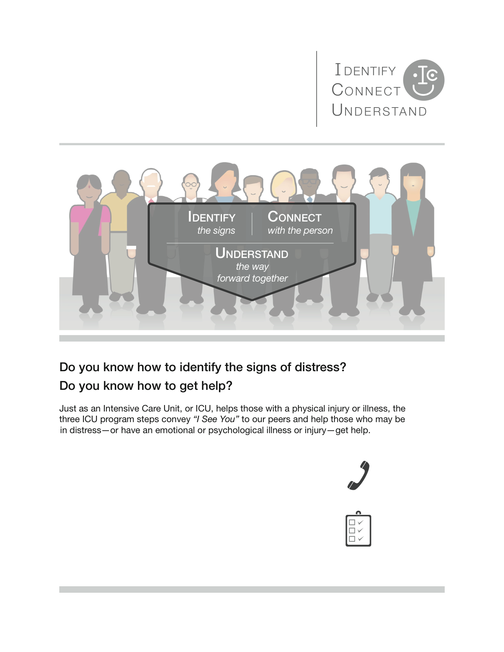

* Contact our Anthem Employee Assistance Program (EAP) at 1 (800) 346-5484. These services are confidential and at no cost to members who participate in the medical plan.
* Contact the EAP offered through our disability carrier, Lincoln Financial Group/Compsych at 1 (888) 628-4824. There is no cost to members.
* Contact Anthem’s member services at 1 (833) 831-0085 if you are unsure of your mental health benefits covered under the health plan.
* Contact your HR/Benefits department at xxx-xxx-xxxx if you have any questions.

Insert Your logo Here

*(Not to exceed size of the orange box)*