2023 Employee Open Enrollment Instructions

- Go to the website http://vbabenefits.bswift.com.

- Enter in your login information.
If you are a first-time user, or do not know your password, click on the First Time User/Forgot Password link.
NOTE: You will be required to complete multi-factor authentication to access system

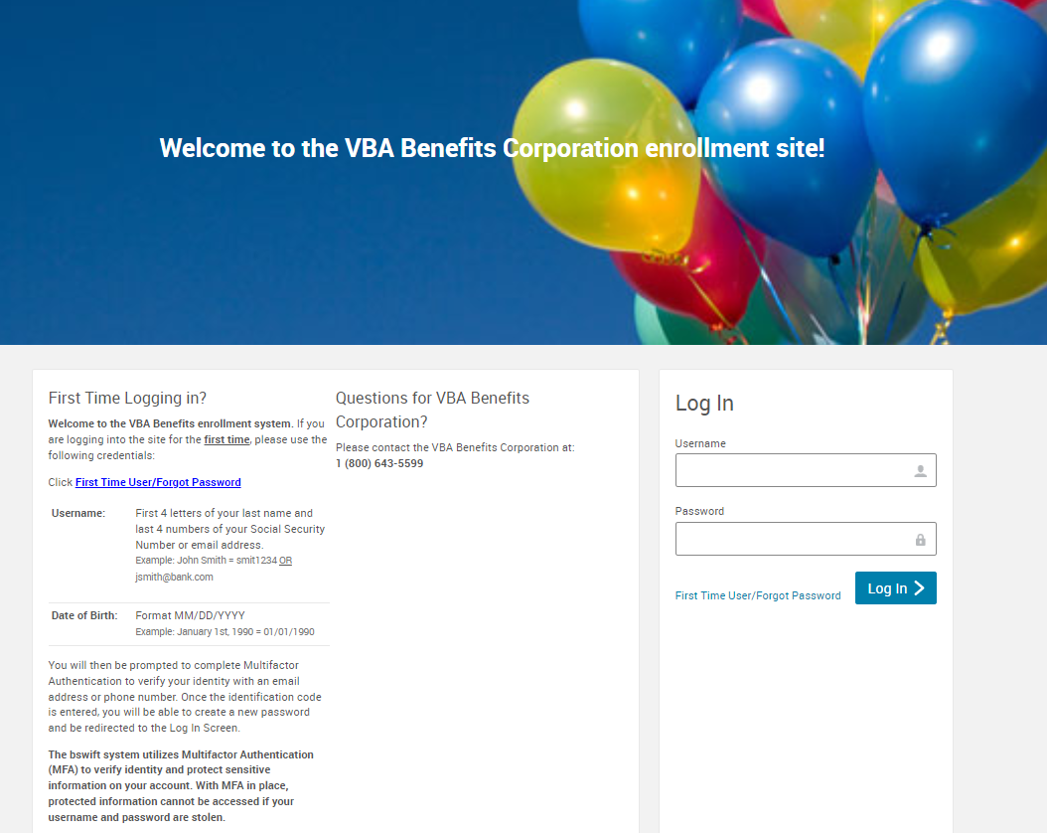

- After logging into your account, it will bring you to the welcome page. To begin open enrollment, click on the “2023Open Enrollment” button in the welcome box

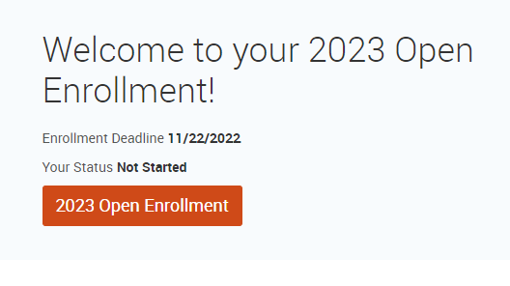
- Employee Information: Make sure your personal information is correct. Fields marked with an asterisk (*) are required. Once complete, scroll to the bottom of this page, select the “I agree” checkbox and continue.

- Family Information: Ensure ALL eligible dependents are listed. NOTE: Because of ACA reporting requirements, you must include even those you do not intend to cover. Once complete, select the “I agree” checkbox and continue.

- Company Wide Enrollment: Now you will be able to select benefits. Elect which plan you want for each benefit type (i.e., medical, dental, vision, etc.) and who you want covered. Choose your plan by clicking “View Plan Options” to display all plans available for the benefit type.
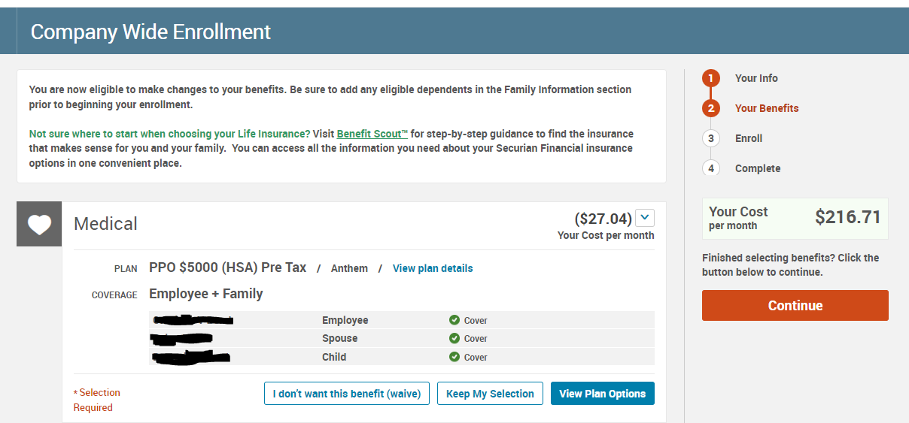

- Click on Select or Keep Selection as desired for each benefit type.
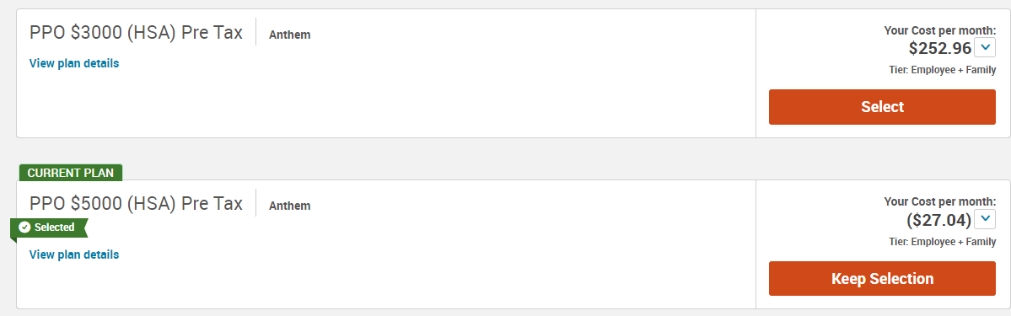

- Once an election is made, a checkmark next to the benefit type will appear and the benefit icon will turn green showing that you have selected a plan for that type. Click Continue.

- Review and Confirm—After clicking on Continue, make sure all your selections are correct. If not, you can click on Edit Selection at the bottom of desired plan description to make changes.
After making sure all your selections are correct, read the participation statement at the bottom of the page and select the “I agree” and then “Complete Enrollment” button to the right of the page.
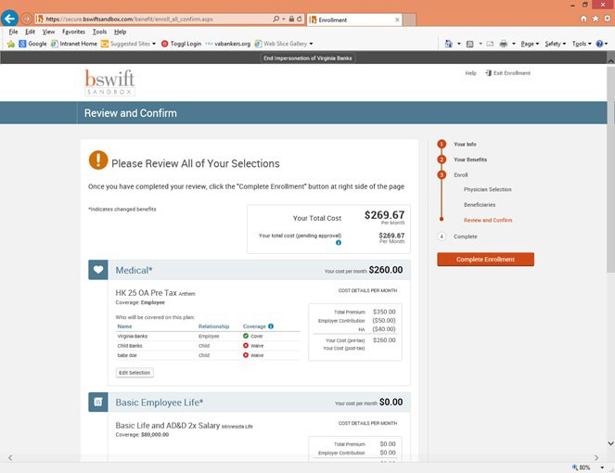

- Now your enrollment is complete! On the next page, you may view the confirmation statement, email it to your preferred email address on file or print it for your records.
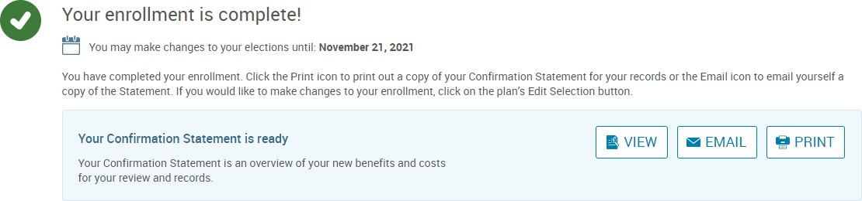

- Enjoy your Benefits!

