2020 Employee Open Enrollment Instructions
- Go to the website http://vbabenefits.bswift.com

- Enter in your login information. Follow the onscreen instructions for logging in (under First Time Logging in?)

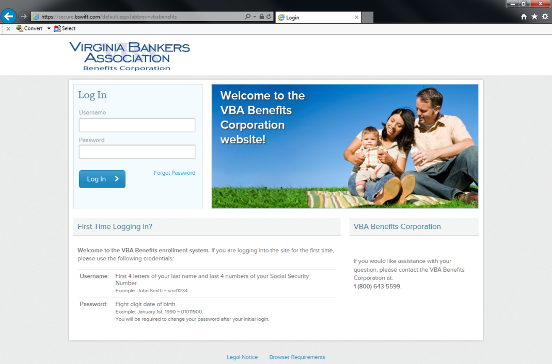

- After logging into your account, it will bring you to the welcome page. To begin open enrollment, click on the “2020 Open Enrollment” button in the welcome box
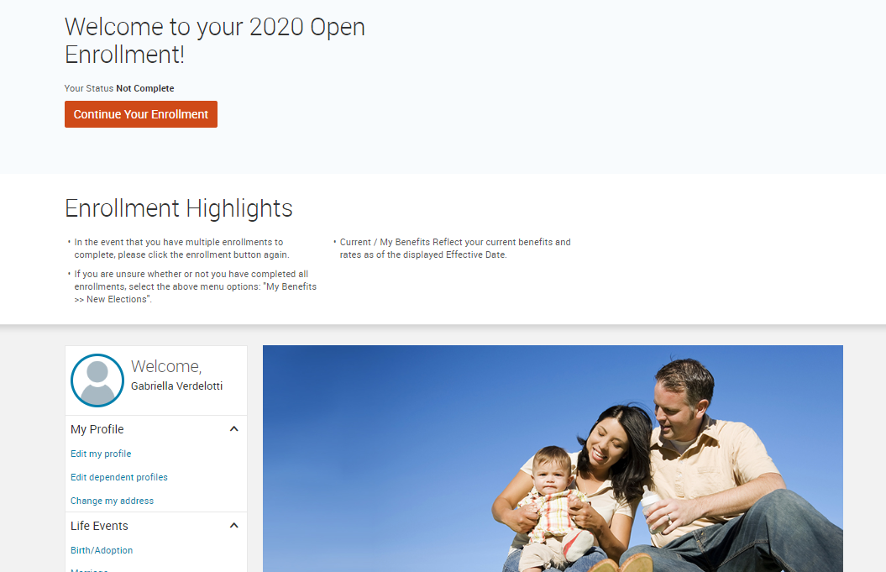

After clicking on “2020 Open Enrollment” it will bring you to an employee information page. Make sure that this information is correct before proceeding. Fields marked with an asterisk (*) are required. At the bottom of this page, select the “I agree” checkbox and continue. It will then prompt you to enter in all dependents (please note, you should log in all dependents for benefits and/or beneficiary purposes). Again, after this is complete, select the “I agree” checkbox and continue.

- Now you will be able to select benefits on the “Select Your Benefits” screen. You elect which plan you want for each plan type (i.e. medical, dental, vision, etc.) and who you want covered. Choose your plan by clicking “View Plan Options” and “select or keep plan option” button for each plan type. A checkmark next to the plan type will appear showing that you have selected a plan for that type.

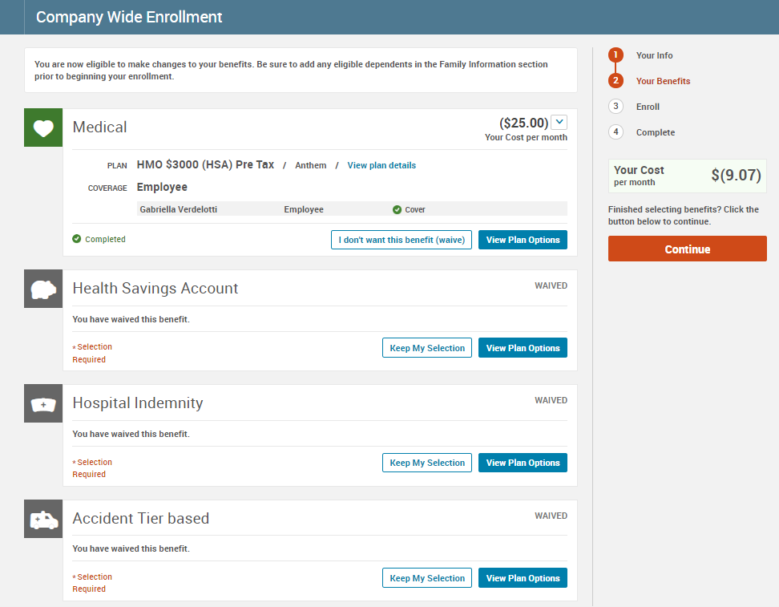

- After electing all of your plans, you will be brought to a confirmation screen. This will display all your selections. Here, please make sure that all your selections are correct. If not, you can click on a specific section from the menu bar on the right of the page in order to make changes in a specific section. After making sure all your selections are correct, please read the participation statement and select the “I agree and “Complete Enrollment” button to the right of the page.
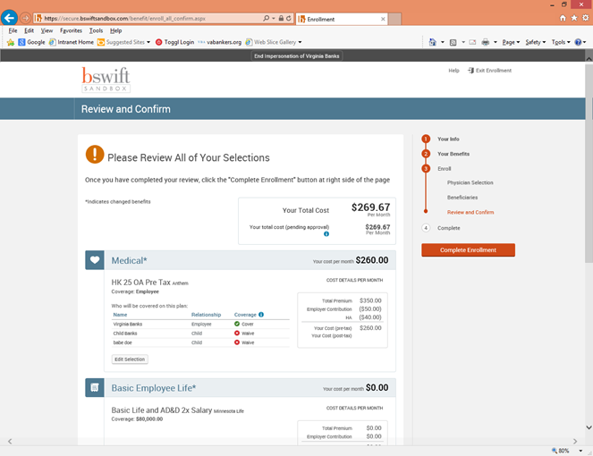

- Now your enrollment is complete! On the next page, you may view the confirmation statement, email it to your preferred email address on file or print it for your records. Enjoy your benefits for 2020!

