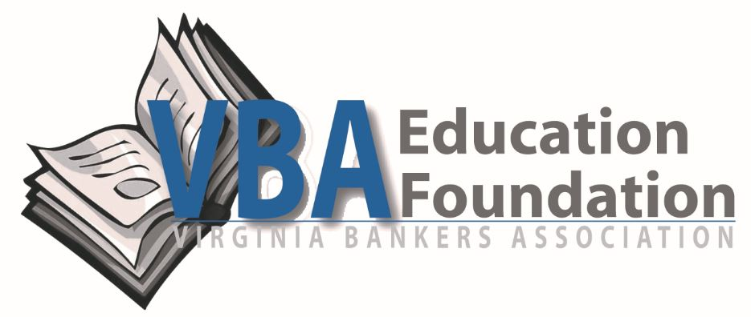
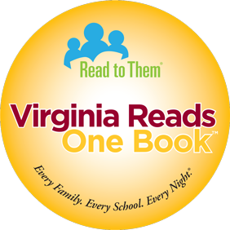
[bank logo]

For Immediate Release
[Date]
MEDIA CONTACTS:
[Bank Contact Information]

Chandler Owdom
Virginia Bankers Association
804-819-4707
cowdom@vabankers.org
Christa Donohue
Read to Them
804-367-3195
christa.donohue@readtothem.org
[Bank Name] Proud to Sponsor [School Name(s)] for Virginia Reads One Book
[City], VA — More than 14,100 Virginia students and their families are reading the same book on the same schedule during the month of March thanks to more than $61,000 of financial support from Virginia’s banking industry. It’s all part of Virginia Reads One Book — a statewide family literacy program designed to strengthen the educational connection between home and school from Richmond-based Read to Them. [Bank name] is a proud sponsor of this program at [school name(s)], where more than [number of] students and staff will participate.
Virginia Reads One Book kicks off on [date if different than March 1, 2021]. During this three-week program, elementary students across Virginia will be involved in school and community events virtually. “The program not only boosts students’ reading abilities, but it shows them reading is fun in an atmosphere that strengthens family and community interactions,” says Read to Them Executive Director Christa Donohue. “With the support of [bank name], the [school(s)] receive a book for every student and complimentary staff copies, both family literacy and financial literacy activities, school assembly suggestions, teacher resources, and both family and community engagement tools. These resources turn a book into a community experience so everyone can enjoy and share the story.”
Each student will receive a copy of the same book, The Trumpet of the Swan by E. B. White. “Our statewide reading schedule will take about 15 minutes each night,” says Donohue, “putting the entire community literally on the same page. Their reading will be augmented with virtual classroom activities, trivia contests, prizes and fun opportunities for family engagement.”
[Banker] stated, “We are thrilled to be able to sponsor Virginia Reads One Book this year, which builds on other financial literacy efforts that we have going in our community, including [insert bank’s specific financial literacy programs/involvement]. We were drawn to this program by not only the financial literacy focus of the book, but also the idea of bringing families together.” [adjust quote as necessary]
[optional quote from school staff]
“We are proud to again be a statewide sponsor of Virginia Reads One Book. The program not only boosts students’ reading abilities, but it shows them reading is fun in an atmosphere that strengthens family and community interactions,” says Bruce Whitehurst, president and CEO of the Virginia Bankers Association.

For the current list of participating schools in your area, please email christa.donohue@readtothem.org.

About [Bank name]

[Insert company information.]

About Virginia Bankers Association Education Foundation

The Virginia Bankers Association (VBA) formed the VBA Education Foundation in 2007 with funding from the majority of VBA member banks for the Walter Ayers Fund for Financial Education. The Foundation’s mission is to improve personal financial literacy and economic education in all public and private schools in the Commonwealth. The Foundation recognizes the importance of economic education and financial literacy in Virginia and supports the banking industry as a key participant in these areas. For more information, visit www.vabankers.org/vba-education-foundation.
About Read to Them
Read to Them is a Richmond based non-profit promoting family literacy, with programs that have reached over 2 million families in over 3000 schools in all 50 states. When children become successful readers at an early age, academic success follows —increasing high school graduation rates and building the basis for a lifetime of learning and productivity. For more information, visit www.readtothem.org.

###

