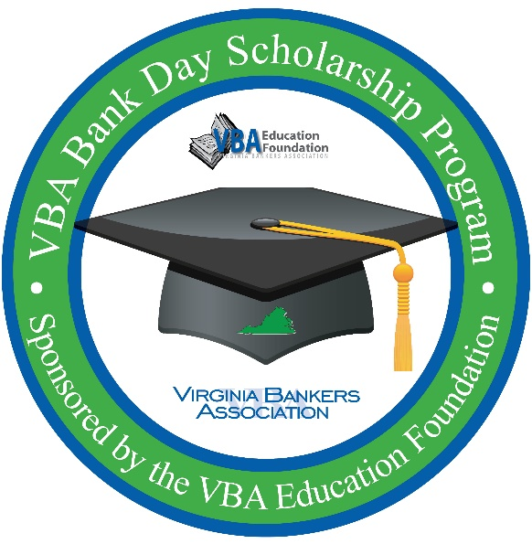
Subject Line – Reminder: Student Registration Closes in Two Weeks for VBA Virtual Bank Day Scholarship Program

Dear [name of teacher, guidance counselor or other school contact],

As a reminder, [Bank Name] is partnering with the Virginia Bankers Association Education Foundation (VBA) to offer your seniors a unique, virtual scholarship opportunity next month called Bank Day. Please note that the student registration for this program closes on Friday, March 5th!

What is Bank Day?
The third Tuesday in March was declared Bank Day by the Virginia General Assembly in 1991. Through this program, high school seniors learn about banking, financial services, career opportunities and the vital role banks play in their communities. From their experience, the students are required to write an essay on their experience. Fourteen scholarships will be awarded on the basis of the essays.

Due to the pandemic, Bank Day will be completely virtual and centralized with content provided from the VBA. Students will have access to a VBA-created Bank Day resource webpage over a three-week window from March 15-April 2, 2021. This resource page will house all relevant information that students will need to research in order to complete their essay for a chance to win college scholarships. [As a virtual host, Bank Name will also be providing supplemental information to your students about ways we support our community (or any other details about other supplemental opportunities you will be offering the students).]

How can your students participate?
In order to participate, students must be currently enrolled as seniors in a Virginia high school with cumulative GPAs of 3.0 or higher. Interested students must register online by March 5th through the VBA using the following link: https://www.formpl.us/form/1724696005.

The week of March 8th, students will be contacted directly by the VBA with more information about the program and a link to access the student resource webpage. Meanwhile, students can learn more about the program on this one-page flyer.

I am hoping that students from [School Name] will be able to participate in this virtual program. Please let me know if you have any questions.

Thank you,

[Name
Title
Bank Name
Contact Information
Bank Logo]

