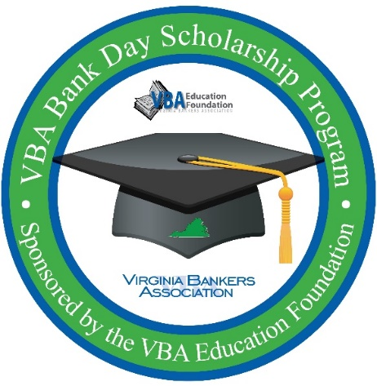
VBA Bank Day Scholarship Program
Student Welcome email template

Please feel free to edit this email template to send to students by Thursday, March 11th.

Good [morning/afternoon],

Thanks for registering to participate in Virginia’s virtual Bank Day Scholarship Program! [Bank name] is excited to serve as your virtual host for this year’s program!

This past Monday, March 8th, you should have received a welcome email from the Virginia Bankers Association (VBA) containing all of the information you’ll need to know about participating in the program. You can also access that information here. Included in this email is:
- Welcome message from the VBA Education Foundation
- Virtual tour of the student resource site (students will get access to this site next Monday, March 15th)
- Program timeline
- Essay information
- …and more!

Be sure to check your email next Monday, March 15th, for another email from the VBA with a direct link to the student resource page. [If your bank plans to provide supplemental resources/information: In addition to the wealth of virtual resources provided by the VBA, you will also be receiving information from [bank name] about ways that our bank supports the community next week. Resources/virtual opportunities will include: [list anything your bank plans to send/offer to students.]]

As you are browsing the resources beginning next week, please feel free to contact me with any questions. [Bank name’s] goal is to ensure that from this experience, you learn more about the banking industry, ways to manage your financial future, career opportunities in banking and how banks across Virginia support the communities they serve.

Please respond and confirm that you have received this email!

We hope you enjoy your Bank Day experience and best of luck on your essay!

Warmly,
[Email signature that includes contact information.]

