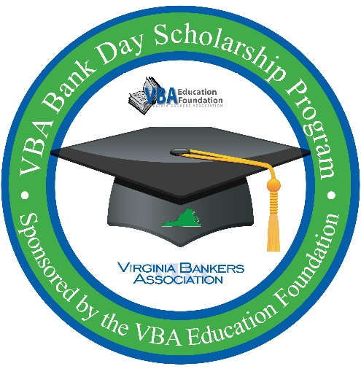
VBA Bank Day Scholarship Program
STUDENT TRIVIA GAME
QUESTIONS & ANSWERS

Bank Day Scholarship Program
- 200 Points What is one way that banks support the schools in the communities they serve?
  - Answers will vary depending on information shared during Bank Day; possible answers include sponsorship, financial literacy presentations, Bank Day Scholarship Program, scholarship opportunities, etc.
- 400 Points How do banks support local businesses in the communities they serve?
  - Answers will vary depending on information shared during Bank Day; possible answers include sponsorship, loans, volunteer hours, etc.
- 600 Points What is the due date for the Bank Day Scholarship Program essay?
  - April 3, 2020 by 5:00 p.m.
- 800 Points In 2020, the Bank Day Scholarship Program will award a total of $______ in scholarships to twelve students.
  - $26,000
- 1,000 Points In 2018, there were more than ______ volunteer hours logged by Virginia banks/bankers.
  - 220,000
Credit Cards & Credit Score
- 200 Points What are two consequences of a poor credit score/rating?
  - Answers will vary depending on information shared during Bank Day; possible answers include:
    - Difficult to qualify for credit cards, loans, mortgages
    - Increase in auto insurance rates
    - Higher rates of interest when borrowing
    - May be declined a cell phone account
    - Can stay on your record a long time (judgments, bankruptcy)
    - May not be able to open a deposit account
    - May be declined to lease an apartment
    - Could prohibit you from receiving a job offer
- 400 Points Credit card minimum payments are usually around ___% of the total balance.
  - 2-3%
- 600 Points How many free credit reports are you legally entitled per year from EACH credit bureau?
  - One credit report from each credit bureau
- 800 Points What are the two biggest influences on your credit score?
  - Payment history and amount of debt
- 1,000 Points What four pieces of information make up your credit report?
  - Personal information, accounts, inquiries and negative items

Banking Basics
- 200 Points What is one advantage of being “banked”?
  - Answers will vary depending on information shared during Bank Day; possible answers include access to money, convenience, safe/insured
- 400 Points The numbers listed at the bottom of a check are the _____ number and the _____ number.
  - Routing, account
- 600 Points Which type of bank account offers the most flexible access to your money with the fewest restrictions?
A. Certificates of Deposits
B. Savings
C. Checking
- 800 Points What is the amount of insurance coverage on deposits by the FDIC?
  - $250,000
- 1,000 Points What are two types/examples of consumer loans?
  - Answers will vary depending on information shared during Bank Day; possible answers include auto loans, education, home equity, home improvement, personal unsecured, etc.
Managing Student Loans
- 200 Points What types of financial aid are considered “free money”?
  - Scholarships and grants
- 400 Points When referring to student loans, what is a grace period?
A. The time period that your library late fees affect your credit score.
B. The time period after graduating high school and before starting college.
C. The period after graduating or leaving school before you must begin paying back student loans.
- 600 Points True or False: FAFSA must be filled out for every school year.
  - True
- 800 Points One of the effects of consolidating your student loans is…
A. It ends any grace period that might still apply to the loan.
B. It increases the amount of money you’ll owe each month.
C. It decreases the amount of money you’ll owe overall.
- 1,000 Points What is the largest supplier of student financial aid in the nation?
  - StudentAid.gov – this division of the US Department of Education is the largest supplier of student financial aid in the nation.

Careers in Banking
- 200 Points On the national level, about how many individuals are employed by banks?
  - 2 million
- 400 Points What is an example of a professional development opportunity that you’ve heard about today?
  - Answers will vary depending on information shared during Bank Day.
- 600 Points What is a perk of a career in banking?
  - Answers will vary depending on information shared during Bank Day; possible answers include job security, plentiful job opportunities, leadership opportunities, opportunities for advancement, challenging work, community service, etc.
- 800 Points What are two jobs in the banking industry for someone interested in technology/IT?
  - Answers will vary depending on information shared during Bank Day; possible answers include electronic banking officer, IT, computer network technician, etc.
- 1,000 Points There are more than ________ bank employees in Virginia.
  - 38,000
Final Question
- What are four ways to avoid debt problems?
  - Answers will vary depending on information shared during Bank Day; possible answers include:
    - Stick to a budget.
    - Maintain a record keeping system.
    - Consider early payoffs, where advantageous.
    - Make sure to live within your means and only use debt that is within a level that your income can support.
    - Make it your goal to eventually live debt free.

