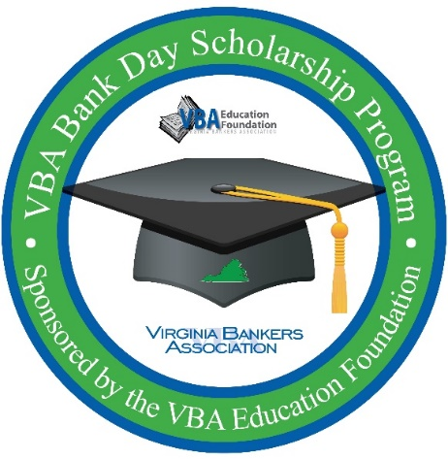
VBA Bank Day Scholarship Program
Student Thank you email template

Things to consider attaching to the email:
- Essay guidelines
- Essay selection criteria
- Essay planning document
- Student evaluation document/link (if you didn’t do a paper evaluation the day of the program)

Good [morning/afternoon student name],

Thanks for participating in Virginia’s Bank Day Scholarship Program hosted at [Bank name]! We all really enjoyed meeting you and hope you learned a lot from the experience.

Essay and Scholarship Information
- Essay Topic: “What did you learn on Bank Day that will help you manage your financial future AND what did you learn about how banks support their communities?”
- Essay is due by 5 p.m. on April 3rd.
- Submit your essay directly to the Virginia Bankers Association (VBA) via email to bankday@vabankers.org
- Questions about the essay should be directed to Monica McDearmon, VBA Communications & Financial Literacy Coordinator, at mmcdearmon@vabankers.org or 804-819-4743.
- Full essay guidelines are attached to this email.
- Essay winning students will be notified at the beginning of May. There will be six $1,000 honorable mention winners and six $2,500 regional winners. Regional winners will be entered into a statewide competition for a chance to receive an additional $5,000 scholarship (total of $7,500). The state-wide winner will be notified mid-May.

You will be receiving a program evaluation link from the VBA in the coming weeks in addition to reminders about submitting your essay.

[Any other bank specific thank you/follow-up information.] Please let me know if you have any questions about anything!

Warmly,
[Email signature that includes contact information.]

