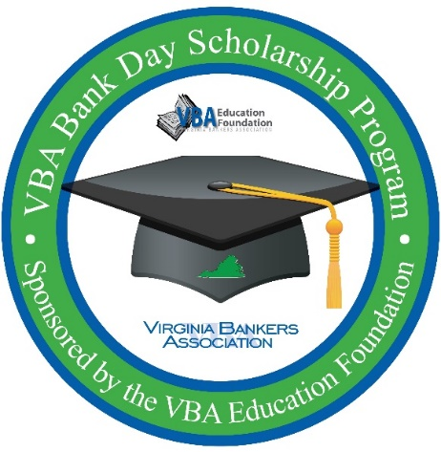
VBA Bank Day Scholarship Program
Student Photo release

For valuable consideration received, I hereby grant to [Bank Name], and the organization’s legal representatives and assigns, the irrevocable and unrestricted right to use and publish photographs of me, or in which I may be included, from my participation in the 2023 Virginia Bankers Association Bank Day Scholarship Program hosted by [Bank Name] on [date], for editorial trade, advertising, and any other purpose and in any manner and medium; and to alter the same without restriction. I hereby release [Bank Name] and the organization’s representatives and assigns from all claims and liability relating to said photographs.

__________________________________________ ____________________________________
Student Signature Date

__________________________________________ ____________________________________
Parent Signature (if student is younger than 18) Date

