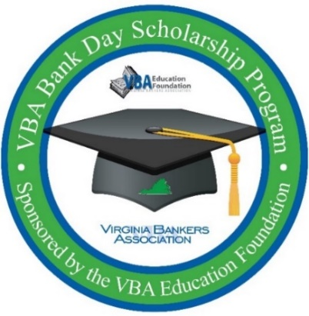**ATTENTION SENIORS:**

**OPPORTUNITY TO WIN   
$7,500 SCHOLARSHIP**

**Virginia Bankers Association   
Bank Day Scholarship program**

**Do you need $7,500 to help pay for your college tuition? Have you always wanted to learn more about the banking industry? If so, consider participating in the Virginia Bankers Association (VBA) Bank Day Scholarship Program in March 2025!**

During this program, you will learn about the banking industry, ways to manage your financial future, careers in banking and the ways banks support their communities. Registered students will be connected with a local bank that will host you and other students for a Bank Day experience as well as provide support during the program. You will also have access to a resource website that houses videos, articles and podcasts to explore and research. From your experience, you will write an essay based on what you’ve learned and these essays will be judged by bankers from across the Commonwealth. Fourteen scholarships (six honorable mention, six regional, one statewide runner-up and one statewide) will be awarded to the winners.

Scholarship Amounts:

$1,000 Each for six honorable mention scholarships

$2,500 Each for six regional winners

$2,500 Statewide runner-up winner ($5,000 total since all candidates will also be regional winners)

$5,000 Statewide winner ($7,500 total since all candidates will also be regional winners)

Participation Criteria:

* Currently enrolled as a high school senior in a Virginia high school
* Cumulative GPA of 3.0 or higher
* Resident of Virginia
* Teacher/guidance counselor contact information provided by student

2025 Deadlines & Important Dates:

February 28: Deadline to sign-up for the program.

March 3-28: Bank Day window – students have access to VBA Bank Day resource website and engage with host bank.

March 28: Student essays are due to the VBA by 5 p.m.

Late April: Regional and honorable mention winners notified. Regional winners will be entered into the statewide contest for additional scholarships.

Early May: Statewide runner-up and statewide winner notified.

**Interested students must register by February 28 online here:**

[**https://forms.office.com/r/SgdDztqqxq**](https://forms.office.com/r/SgdDztqqxq) **Questions? Contact Monica McDearmon, VBA Vice President, Communications & Financial Education, at** [**mmcdearmon@vabankers.org**](mailto:mmcdearmon@vabankers.org)**.**