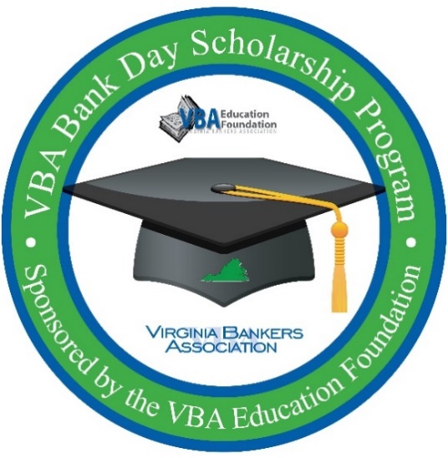
ATTENTION SENIORS:
OPPORTUNITY TO WIN
$7,500 SCHOLARSHIP

Virginia Bankers Association
Bank Day Scholarship program

Have you always wondered what actually goes on inside a bank? Do you need $7,500 to help pay for your college tuition? If so, consider participating in Bank Day.

On this day, you will spend a day in a bank shadowing a banker in their daily duties. After the day, you will write an essay based on your experience. These essays will be judged by bankers and thirteen scholarships (twelve regional and one statewide) will be awarded to the winners.

Bank Day will take place on [Tuesday, March 17, 2020].
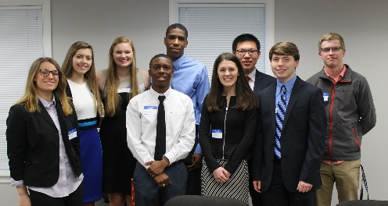
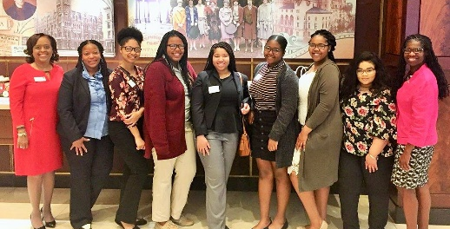
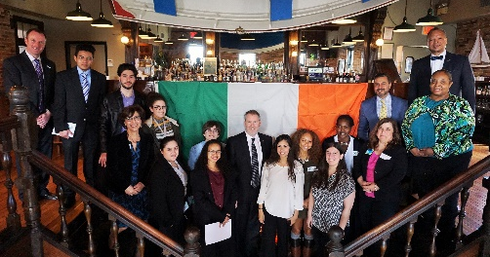

Scholarship Amounts:
$1,000 Each for six honorable mention scholarships
$2,500 Each for six regional winners
$5,000 Statewide winner ($7,500 total since all candidates will also be regional winners)

Participation Criteria:
Currently enrolled as a high school senior in a Virginia high school
Cumulative GPA of 3.0 or higher
Resident of Virginia
Teacher/guidance counselor contact information provided by student

Deadlines & Important Dates:
March 10, 2020: Deadline to sign-up for the program.
March 17, 2020: Bank Day! Shadowing takes place.
April 3, 2020: Student essays due by 5 p.m. Essays submitted directly to VBA via email.
April 24, 2020: Regional and honorable mention winners notified. Regional winners will be entered into the statewide contest for an additional $5,000 scholarship.
May 4, 2020: State winner notified.
Interested? Contact [bank contact/guidance counselor] for more information.

