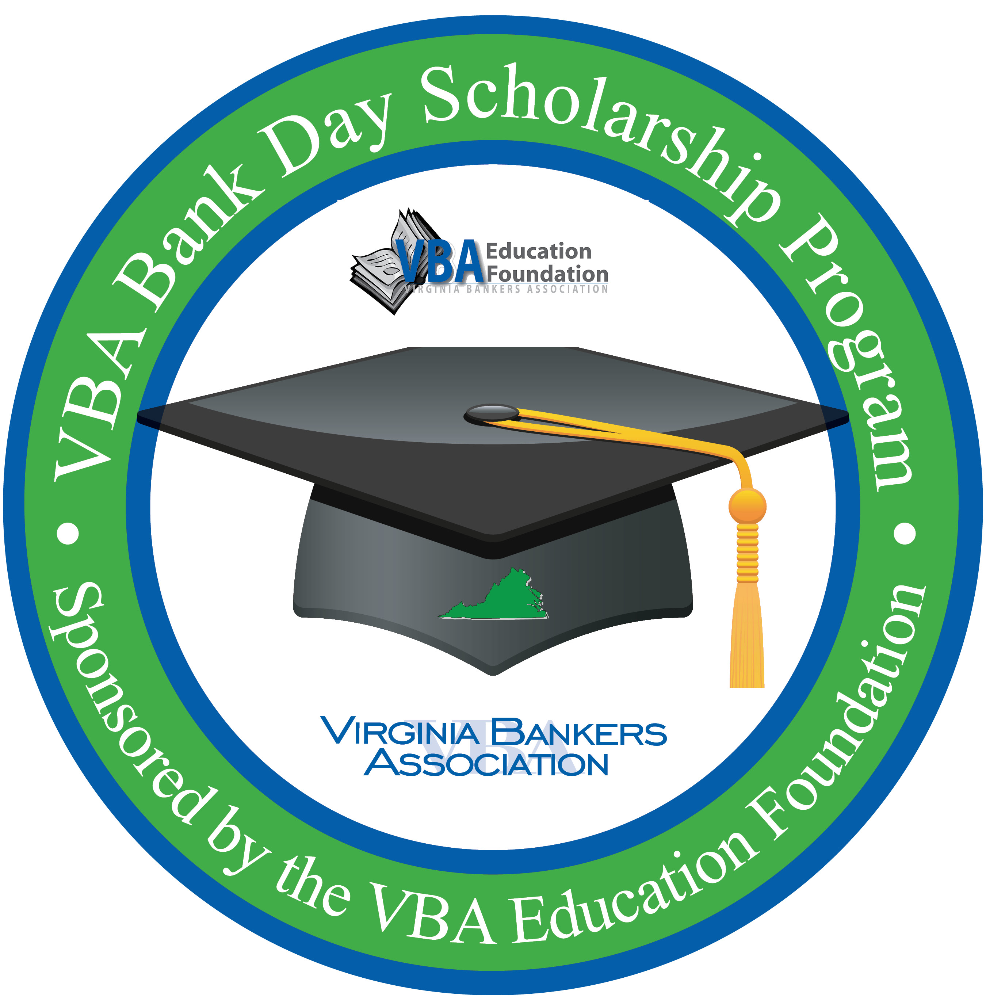
VBA Bank Day Scholarship Program
STUDENT EVALUATION
PRESENTED BY [BANK NAME] | [DATE]
Please answer each of the statements below as thoughtfully and carefully as possible. Your responses and comments are very important to us as part of our continuing efforts to offer a quality VBA Bank Day Scholarship Program.

- What was your favorite part of the day?

- What do you feel was missing from the program today?

- Do you feel that communication from the VBA and the bank was sufficient in the days/weeks leading up to Bank Day? If no, what could we have done differently?

- How can we improve the program next year?

- What was the most interesting thing you learned today?

- Are you leaving today with enough information to be able to write your essay? What topics do you still feel unsure of?

- How did you learn about the Bank Day Scholarship Program (check all that apply)?
□ Teacher
□ Guidance counselor
□ Sibling was a past participant
□ Parent/guardian
□ Friend
□ Banker
□ Other: _______________________________________________

Additional Comments:

