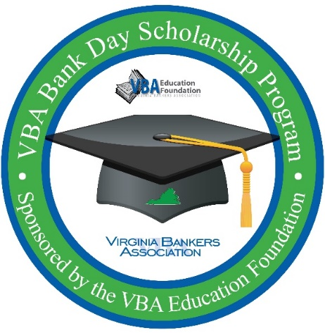
VBA Bank Day Scholarship Program
Student confirmation email template

Things to consider attaching to the email:
- Essay guidelines
- Copy of the agenda (for either in-person or virtual gathering)
- Menu for lunch pre-order (if applicable)
- Bank’s specific photo release (if applicable – remember all students sign the VBA photo release during the registration process)

Good afternoon [student name],

Thanks for registering to participate in the Virginia Bankers Association (VBA) Bank Day Scholarship Program hosted by [Bank name]! We are all really looking forward to meeting you! This email contains everything you need to know about participating in Bank Day. This is a lot of information in this email and there are [x number of] items in this email that requires some action: [list items that need action, like lunch pre-order or signing photo release] so please make sure to read it all the way through. If you have any questions, please reach out to me via phone or email (you’ll find my contact information below).

This past Monday, March 7th, you should have received a welcome email from the VBA containing all the information you’ll need to know about participating in the program. Included in this email is:
- Welcome message from the VBA Education Foundation
- Virtual tour of the student resource site (students will get access to this site next Monday, March 14th)
- Program timeline
- Essay information
- …and more!

Be sure to check your email next Monday, March 14th, for another email from the VBA with a direct link to the student resource page.

[If you’re hosting students in-person, please fill in the blanks below. If you are hosting students virtually, adjust to include virtual meeting access information, date, time, etc.]:
When is Bank Day?
March [date your bank is hosting students] from [x] a.m. to [x] p.m.

Where is Bank Day?
- [Bank address information. You can also consider including a picture of the front of the building so students know what they’re looking for.]
- [Information on where the students are to go when they get inside the building and specific location where a banker will meet them.]
- [Any parking information they need to know.]

What to Wear to Bank Day:
[Bank name] practices a business professional dress code at our branches and offices. Please arrive wearing professional attire. Examples of professional attire are:
- Collared dress shirt or blouse
- Slacks, dress pants, khakis, or skirt (no more than 2-3 inches above the knee)
- Cardigans are acceptable
- [any other specific examples your bank would like to provide]

Agenda for Bank Day
[Include information about lunch. If students need to pre-order lunch, please include that information here!]
[Specific agenda information or consider attaching the agenda to the email.]

Contact Information
If you need to contact me before the event, my contact information is listed below. My cell phone is [phone number]. [I am open to phone calls or texts.] You are welcome to share my contact information with your parents or teachers! [If you have a cell phone, you are welcome to keep that on and with you during your time here at the bank.]

Photo Release [if you’re requiring a photo release in addition to the release they signed during the registration process with the VBA]
We would love to take some pictures of how much fun we are having on Bank Day and be able to share those on our social media sites and with the VBA. To do that, we need your permission! [Information about bank specific photo release. For example: If you can print, sign, and return the photo release attached via email or bring with you on Bank Day we would appreciate it! If you are younger than 18, please ask a parent to sign the photo release as well. REMINDER – all students signed the VBA photo release when they registered for the program.]

Please respond and confirm that you have received this email and RSVP to our [in-person/virtual] gathering by [X date].

As you are browsing the resources beginning next week, please feel free to contact me with any questions. [Bank name’s] goal is to ensure that from this experience, you learn more about the banking industry, ways to manage your financial future, career opportunities in banking and how banks across Virginia support the communities they serve.

Warmly,
[Email signature that includes contact information.]

