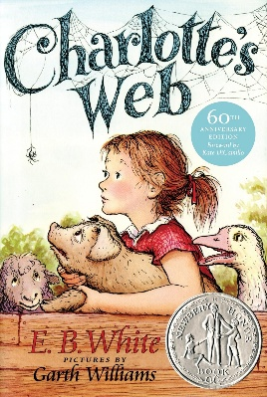
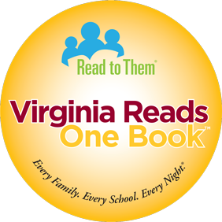

2026 Virginia Reads One Book - Social Media Post Ideas
Use Image: General or with Quote
- [Bank Name] is proud to sponsor [school name(s)] for the 2026 Virginia Reads One Book program beginning in March. Through the #VAROB2026 program, we aim to build a community of readers. Everyone – students, parents, teachers, and even administrative staff - will be following along together while reading this year’s financial literacy themed book, Charlotte’s Web. The students and staff at [school name(s)] will join more than 33,000 Virginia students participating in this program. “When a whole state reads a book, there’s a lot to talk about.” #vabankers @readtothem @vabankers [any other bank specific hashtags]
Use Image: One Month Out
- Next month, more than 33,000 Virginia students will participate in #VAROB2026 and [bank name] is a proud sponsor of [school name(s)]! Through this program, the entire school community - including bus drivers, resource teachers, facilities staff, office personnel, students and their families - read the same financial literacy themed book on the same schedule. Be sure to follow [bank name] on [social media channel(s)] for updates on the program throughout the month of March. #vabankers @readtothem @vabankers [any other bank specific hashtags]
Use Image: One Week Out
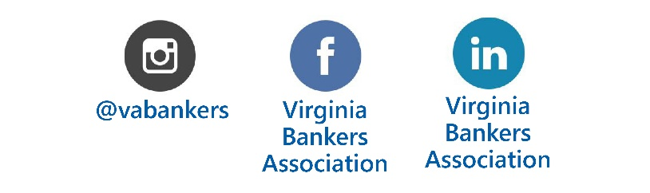
- “When a whole state reads a book, there’s a lot to talk about.” [Bank name] is proud to support [school name(s)] for this year’s #VAROB2026 program! Over the next three weeks, students and staff will read this year’s financial literacy themed book, Charlotte’s Web, and participate in a variety of activities that support the themes of the book. #vabankers @readtothem @vabankers [any other bank specific hashtags]

