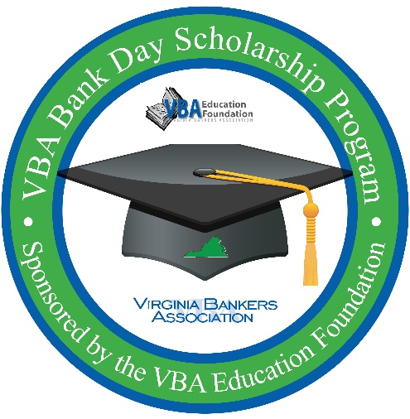
VBA Bank Day Scholarship Program
SOCIAL MEDIA POST IDEAS

Don’t forget to tag @vabankers on Instagram and ‘Virginia Bankers Association’ on your Facebook and LinkedIn posts!
Social media images are available under the Press Kit on the Bank Day resources webpage here.

Student registration link to use in your posts: https://forms.office.com/r/R6U1nbwcv6

Sample Posts:
Do you have a high school senior with at least a 3.0 GPA? Encourage them to participate in the @vabankers Bank Day Scholarship program in March! Participating students will have a chance to win up to $7,500 in college scholarships! To be eligible, students must write an essay explaining what they learned during their experience that will help them manage their financial future and how banks support their communities. Students must be registered by February 27. For more information, contact [bank contact email address]. #vabankers #vbabankday [any other bank hashtag]

One month until @vabankers Bank Day Scholarship Program! [Bank name] is excited to host high school seniors for this important program. Participating students will have a chance to win up to $7,500 in college scholarships. Interested in learning more? Contact [bank contact name/email address]. #vabankers #vbabankday [any other bank hashtag]

We are gearing up for @vabankers Bank Day Scholarship Program! Share this information with your family and friends who have high school seniors who are interested in earning up to $7,500 in college scholarships and interested in a career in banking! Interested students can register online by February 27 here: https://forms.office.com/r/R6U1nbwcv6 #vabankers #vbabankday [any other bank hashtag]

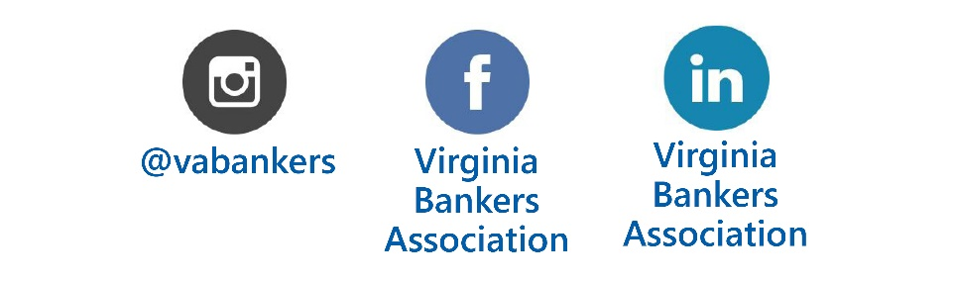
In March, Virginia high school seniors will learn about the banking industry and the vital role community banks play in their communities through the @vabankers Bank Day Scholarship Program. Participating students will be eligible to win up to $7,500 in college scholarships! For more information on how to participate in the program, please contact your school’s guidance department, call us at [phone number] or send an email to [email address]! #vabankers #vbabankday [any other bank hashtag]

