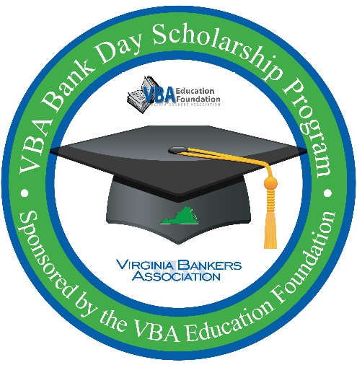
VBA Bank Day Scholarship Program
SAMPLE BANK DAY SCHEDULE

Thank you to Old Point National Bank for sharing their Bank Day
schedule and activity with participating banks!

- Students arrive (approximately 9:15)
  - “Get to know you” activity
  - Introductions
  - Discuss essay topic and guidelines; provide copies of guidelines to students
- Banker talks about bank’s history and community service (9:30-10:00)
  - Consider using customizable Careers in Banking PowerPoint (available in resource manual)
- Overview of assignment for the day (10:00-10:15)
  - Provide students with handouts (see mini presentation handout)
- Send students out to shadowing assignments (10:15-11:45)
  - Send students to different departments at the bank. Possibilities include:
    - Commercial lending department
    - Marketing department
    - HR department
    - Loan department
- Working lunch (11:45-12:30)
  - Bank management attend lunch with students
- Student presentations (12:30-1:30)
- Building tour (1:30-2:00)
  - Include time behind the teller line
  - Consider splitting a larger group into two or three smaller groups
- PowerPoint presentation (2:00-2:30)
  - VBA Bank Day PowerPoint (available in resource manual)
- Finish with talk from on bank’s commitment to the community (2:30-3:00)

**Make sure to have students fill out evaluations at the end of the day (available in resource manual).

VBA Bank Day Scholarship Program
MINI PRESENTATION BASED ON
SHADOWING ASSIGNMENT

Thank you to Old Point National Bank for sharing their Bank Day
schedule and activity with participating banks!

Create a 10-minute or less presentation with your shadowing group for your fellow students. In your presentation, be sure to answer the following questions based on your shadowing assignment area:
- How does this area of the bank help customers?

- How does this area of the bank make money (directly or indirectly) for the bank?

- How does the individual you shadowed help the local community (directly or indirectly)?

- What part of the department do you find most interesting?

- How has your shadowing assignment changed your view on personal financial management?

