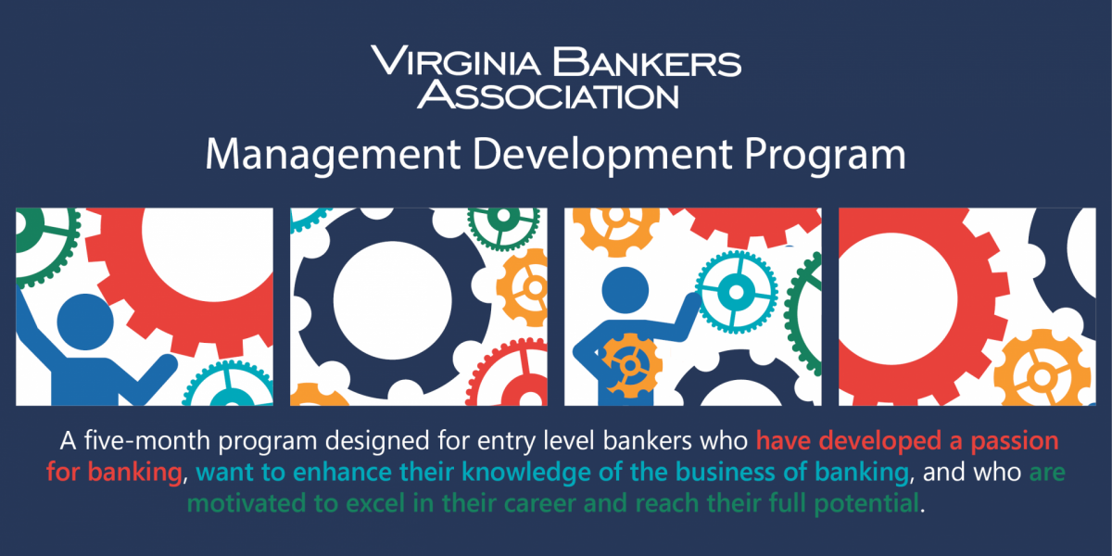

**Session 2**

**Insights Discovery: Learning Your Personal Leadership Style**

October 12, 2022

Reflection Prompts

Serena Fulton

Serena@floricane.com

www.floricane.com

**My Leadership Effectiveness**

*Reference your profile and/or any of your notes from the content we covered so far today.*

1. To me, leadership effectiveness means…
2. When my leadership is most effective, I am… (reference overview, strengths, value to the team, effective communication, motivation, ideal environment)
3. What needs to be in place for you to be effective?
4. When my leadership is least effective, I am… (reference overview, weaknesses, barriers to effective communication, blind spots)
5. What gets in your way from being your most effective?

**What Motivates Me**

Read the Motivating You page in the Management chapter of your Insights Discovery Personal Profile, think about your current working environment, and mark the statements as follows:

H = High – this is a high motivator for you

M = Medium – this is a medium motivator for you

L = Low – this is a low motivator for you

Looking at the high and medium motivators, allocate the following scores:

3 = This is definitely in place for me now

2 = This is sometimes in place for me now

1 = This is currently missing

Look at anything scored 1 and reflect upon the following questions.

What is blocking this at the moment?

What can you do to overcome this?

Who can support you to provide this?

**My Leadership Under Stress**

PART 1

1. What situations cause you stress in the workplace? Capture at least 3 specific examples.
2. When or how do you know you’re under stress?
3. How do you react to stress? What behaviors emerge? What will people typically observe when you are under stress?

PART 2



1. Looking at the situations you cited previously, what might be the source or cause of your stress in each example?
2. What causes are outside of your control? Are there any stress causes or factors within your control?



1. What is something within your control you can do to prevent or alleviate stress? How might you help yourself recover during a stress response?
2. What is something you can ask others to do to support preventing or alleviating your stress? How can others help you recover during a stress response?

**My Action Plan**

1. What are your core leadership strengths that you can build on and amplify?
2. What do you need to lead effectively?
3. What challenges do you anticipate for yourself and your team in the next 3-6 months?
4. How might you support your team in a way that leverages your best leadership?