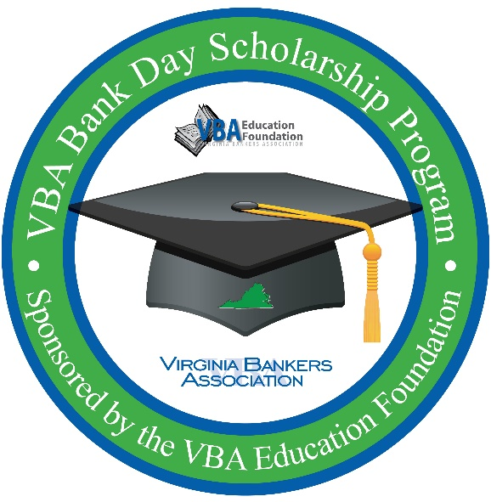
VBA Bank Day Scholarship Program
Important dates

Mark your calendar now!

March 10, 2020: Deadline for students to sign-up for the program.

March 17, 2020: Bank Day! Shadowing takes place.

April 3, 2020: Student essays due by 5 pm. Essays submitted directly to VBA via email.

April 24, 2020: Regional and honorable mention winners notified. Regional winners will be entered into the statewide contest for an additional $5,000 scholarship.

May 4, 2020: State winner notified.

Please contact [bank contact] at [email] or [phone number] with any questions.

