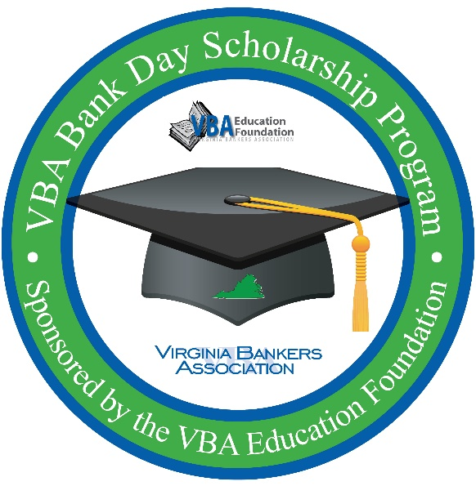
Virginia Bankers Association
Bank Day Scholarship program

Dear [name of teacher or guidance counselor],

I wanted to let you know about an important scholarship program for high school seniors called Bank Day. The third Tuesday in March was declared Bank Day by the Virginia General Assembly in 1991. On this day, high school seniors spend a day in banks across the Commonwealth shadowing a banker in their daily duties. The purpose of this experience is for the students to learn about banking, financial services, and the vital role banks play in their communities.

From their experience, the students are required to write an essay on their experience. Thirteen scholarships will be awarded on the basis of the essays.

This year, Bank Day will take place on Tuesday, March 17th, and [bank name] will be participating. I am hoping that we could discuss this program, so that students from [school name] will be able to participate in this program at our bank. In order to participate, students must be currently enrolled as seniors in a Virginia high school with cumulative GPAs of 3.0 or higher.

These students would have the opportunity to win one of six $2,500 regional scholarships that are offered. The regional winners are also entered to win an additional $5,000 scholarship that is awarded to the statewide winner. There will also be six honorable mention scholarships of $1,000 (one in each of the six regions). In all, $26,000 worth of scholarships are awarded through this program.

I’ve also included informational pieces such as a fact sheet, a list of important dates and deadlines, a sample Bank Day schedule and a flyer with information about the program for classrooms or the guidance department.

I hope that you will contact me about this program so that I can give you more information and we can plan for Bank Day in March. I look forward to talking with you soon.

Thank you,

[Name
Title
Bank Name
Contact Information]

