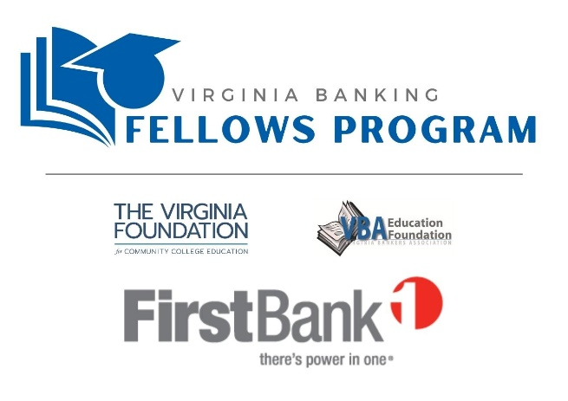
[Fellow’s Name],
Congratulations on being selected as a Virginia Banking Fellow! The Fellows program is an opportunity for you to participate in important leadership activities and gain valuable insight from industry professionals who will help you succeed in your future career.
You are joining a cohort of 13 students in the pilot Virginia Banking Fellows Program for the 2022-2023 school year. Your participation in this program is being sponsored by [bank name] and supported by the Virginia Bankers Association (VBA) Education Foundation and the Virginia Foundation for Community College Education (VFCCE).
Through this program, not only will you strengthen your leadership skills and expand your community involvement through a variety of activities with all VFCCE Fellows, but you will also have access to banking industry events, online training and networking opportunities. Our goal is that through this program, you will learn more about the Virginia banking industry, the ways we support our community and the variety of career opportunities available in the banking industry!
We look forward to meeting you in September at the orientation session. More information about the orientation will be available soon. In the meantime, please feel free to reach out to me at any time with questions that you have about the program.

Sincerely,

[Bank contact name]
[Bank contact phone number]
[Bank contact email address]
[Bank website]

