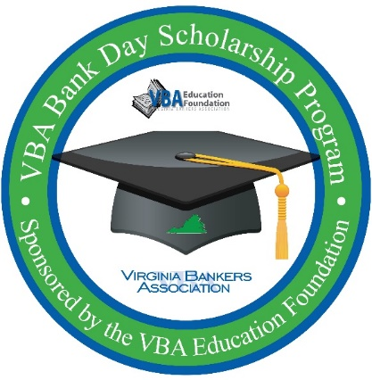**Virginia Bankers Association**

**Bank Day Scholarship program**

Dear [**name of teacher, guidance counselor or other school contact**],

**[Bank Name]** is excited to partner with the Virginia Bankers Association Education Foundation (VBA) to offer your seniors a unique scholarship opportunity in March called Bank Day.

**What is Bank Day?**

The third Tuesday in March was declared Bank Day by the Virginia General Assembly in 1991. Through this program, high school seniors learn about banking, financial services, career opportunities within the banking industry and the vital role banks play in their communities. From their experience, the students are required to write essays about what they learned during the program. Fourteen scholarships will be awarded on the basis of the essays.

**[Bank Name will also be hosting students (in person/virtually) on X date for an opportunity to learn more about our bank, the banking industry in Virginia, how we support our community and (any other details about what you are planning for students during your Bank Day gathering). More details about this gathering will be shared with students upon registration. Please note that attendance on X date is mandatory in order for the participating students to be eligible for the scholarship.**

**We will also be providing supplemental information to your students about (details about other supplemental opportunities you will be offering the students, if any).]**

Students will also have access to a VBA-created Bank Day resource webpage during the month of March that houses relevant information that students will need to research in order to complete their essays for a chance to win college scholarships.

**How much scholarship money is available?**

A total of $28,500 will be awarded to twelve students across the Commonwealth.

* Six honorable mention winners, each winning a $1,000 scholarship.
* Six regional winners, each winning a $2,500 scholarship.
* One of the regional winners will be named the statewide runner-up winner, earning an extra $2,500 scholarship for a **total of $5,000 in college scholarships.**
* One of the regional winners will also be named the statewide winner, earning an extra $5,000 scholarship for a **total of $7,500 in college scholarships.**

**How can your students participate?**

In order to participate, students must be currently enrolled as seniors in a Virginia high school with cumulative GPAs of 3.0 or higher. Interested students must register online by February 28 through the VBA using the following link: <https://forms.office.com/r/SgdDztqqxq>.

In early March, students will be contacted directly by the VBA with more information about the program and a link to access the resource webpage. Meanwhile, students can learn more about the program on the attached flyer. **[If you plan to attach PDF to the email that has your bank specific information included.]**

I am hoping to discuss this program with you further, so that students from [**School Name**] will be able to participate. I look forward to hearing from you soon.

Thank you,

[**Name**

**Title**

**Bank Name**

**Contact Information  
Bank Logo**]