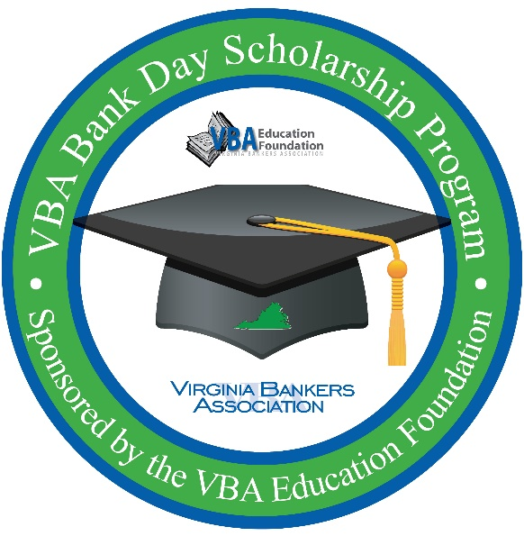
Virginia Bankers Association
Bank Day Scholarship program

Dear [name of teacher, guidance counselor or other school contact],

[Bank Name] is excited to partner with the Virginia Bankers Association Education Foundation (VBA) to offer your seniors a unique scholarship opportunity in March called Bank Day.

What is Bank Day?
The third Tuesday in March was declared Bank Day by the Virginia General Assembly in 1991. Through this program, high school seniors learn about banking, financial services, career opportunities within the banking industry and the vital role banks play in their communities. From their experience, the students are required to write essays on their experiences. Thirteen scholarships will be awarded on the basis of the essays.

Students will have access to a VBA-created Bank Day resource webpage over a three-week window from March 13-31, 2023. This resource page will house relevant information that students will need to research in order to complete their essays for a chance to win college scholarships. [Bank Name will also be hosting students (in person/virtually) on X date for an opportunity to learn more about our bank, the banking industry in Virginia, how we support our community and (any other details about what you are planning for students during your Bank Day gathering). More details about this gathering will be shared with students upon registration. We will also be providing supplemental information to your students about (details about other supplemental opportunities you will be offering the students, if any).]

How much scholarship money is available?
A total of $26,000 will be awarded to twelve students across the Commonwealth.
- Six honorable mention winners, each winning a $1,000 scholarship.
- Six regional winners, each winning a $2,500 scholarship.
- One of the regional winners will also be named the statewide winner, earning an extra $5,000 scholarship for a total of $7,500 in college scholarships!

How can your students participate?
In order to participate, students must be currently enrolled as seniors in a Virginia high school with cumulative GPAs of 3.0 or higher. Interested students must register online by March 3rd through the VBA using the following link: https://www.formpl.us/form/5373805918814208.

In March, students will be contacted directly by the VBA with more information about the program and a link to access the resource webpage. Meanwhile, students can learn more about the program on this one-page flyer.

[If you plan to attach PDF to the email - I’ve also attached the flyer with information about the program for classrooms or the guidance department.]

I am hoping to discuss this program with you further, so that students from [School Name] will be able to participate. I look forward to hearing from you soon.

Thank you,

[Name
Title
Bank Name
Contact Information
Bank Logo]

