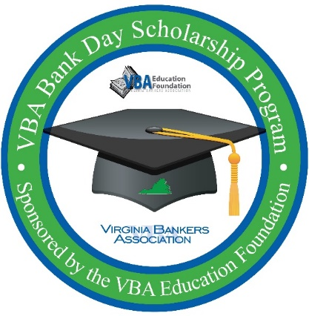**Subject Line – Reminder: Student Registration Closes in Two Weeks for VBA Virtual Bank Day Scholarship Program**

Dear [**name of teacher, guidance counselor or other school contact**],

As a reminder, **[Bank Name]** is partnering with the Virginia Bankers Association Education Foundation (VBA) to offer your seniors a unique scholarship opportunity next month called Bank Day. **Please note that the student registration deadline for this program is Friday, February 28.**

**What is Bank Day?**

The third Tuesday in March was declared Bank Day by the Virginia General Assembly in 1991. Through this program, high school seniors learn about banking, financial services, career opportunities within the banking industry and the vital role banks play in their communities. From their experience, the students are required to write essays about what they learned during the program. Fourteen scholarships will be awarded on the basis of the essays.

**[Bank Name will also be hosting students (in person/virtually) on X date for an opportunity to learn more about our bank, the banking industry in Virginia, how we support our community and (any other details about what you are planning for students during your Bank Day gathering). More details about this gathering will be shared with students upon registration. Please note that attendance on X date is mandatory in order for the participating students to be eligible for the scholarship.**

**We will also be providing supplemental information to your students about (details about other supplemental opportunities you will be offering the students, if any).]**

Students will also have access to a VBA-created Bank Day resource webpage during the month of March that houses relevant information that students will need to research in order to complete their essays for a chance to win college scholarships.

**How can your students participate?**

In order to participate, students must be currently enrolled as seniors in a Virginia high school with cumulative GPAs of 3.0 or higher. Interested students must register online by March 1st through the VBA using the following link: <https://forms.office.com/r/SgdDztqqxq>.

In early March, students will be contacted directly by the VBA with more information about the program and a link to access the resource webpage. Meanwhile, students can learn more about the program on the attached flyer. **[If you plan to attach PDF to the email that has your bank specific information included.]**

I am hoping that students from [**School Name**] will be able to participate. Please let me know if you have any questions.

Thank you,

[**Name**

**Title**

**Bank Name**

**Contact Information  
Bank Logo**]