Banking 101 Participant Guide
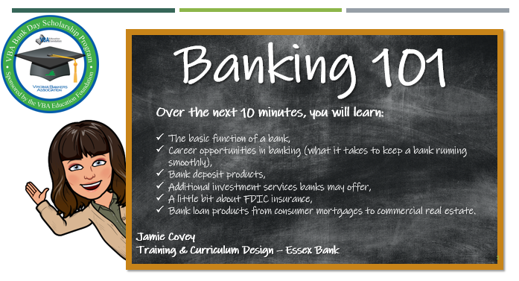
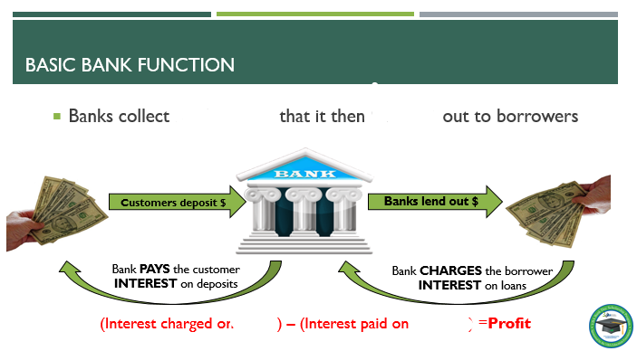

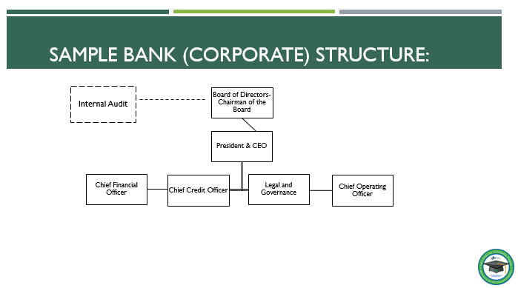Corporate Structure:
Board of Directors: consists of individuals outside of the organization who make impartial judgements on behalf of shareholders and investors.

President & CEO: reports to the Board of Directors. He/she is responsible for the bank’s entire operations. The CEO should implement the board’s decisions and act as the “top manager” of the bank.

Internal Audit: independently reports to the Board of Directors and Executive management to ensure the bank is operating smoothly and soundly, with proper controls, policies, and procedures in place.

Executive Management (the “C” suite): reports to the President & CEO. This group is mostly responsible for day to day management of the bank.
Chief Financial Officer- typically manages the bank’s accounting and finance division and
is responsible for managing the bank’s finances as a whole, including making financial
decisions for the bank (like helping the bank set its interest rates).

Chief Credit Officer- typically manages the credit division of the bank and is responsible
for managing all of the bank’s loans and loan functions. This individual typically sets the
stage for the bank’s lending policies.
Chief Operating Officer – typically manages all bank operations and the bank’s IT
Department. He/she is responsible for overseeing the day to day operating of the bank
which includes ensuring the bank’s core operating system and major reporting.

Chief Risk Officer- typically manages the Risk and Compliance department. He/she is
responsible for managing the bank’s risk and making sure that all operating policies and
procedures are in compliance with regulatory guidelines.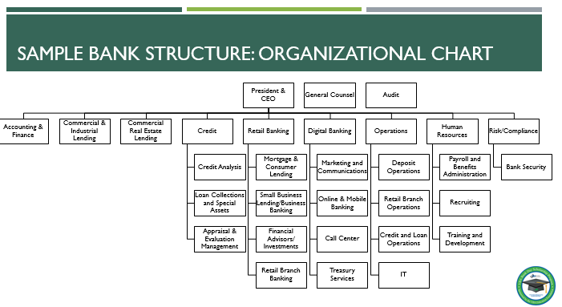
Sample Organizational Structure
You can “google” any one of these roles to get a little more information on specific function
Accounting and Finance
Commercial / Industrial Lending and Commercial Real Estate Lending
Credit
Retail Banking
Digital Banking
Operations
Human Resources
Risk/Compliance

Bank Deposit Product Matching
Match the Product on the left to the correct description on the right
 | - Checking Account | - A “liquid” investment account where funds are deposited and earn modest interest. They are great for ‘emergency funds’ and short term savings goals. They have limitations on how and how often funds can be withdrawn.
 | - Certificate of Deposit (CD) | - An account that is used exclusively for the retirement savings that comes with strict IRS rules on the use of funds and contribution limits. They are typically held in a certificate of deposit.
 | - Savings Account | - An account where funds are deposited and can be withdrawn using checks, debit card, online transaction…funds are ‘on demand’. These accounts are used for everyday use.
 | - Health Savings Account (HSA) | - An investment account where funds are deposited for a specific length of time earning a fixed interest rate during that time. Funds cannot be withdrawn until the end of the specific term, without paying a penalty.
 | - Individual Retirement Account (IRA) | - An investment account where funds are deposited, earn higher interest than saving accounts, and can be accessed at an ATM, bank branch, check writing, and debit card within certain limitations. They are a hybrid between savings and checking accounts.
 | - Money Market Account | - A checking account where funds are deposited and are used to pay for medical expenses, tax free. There are strict IRS rules to follow on account use, contribution limits, and the kind of health insurance that qualifies.

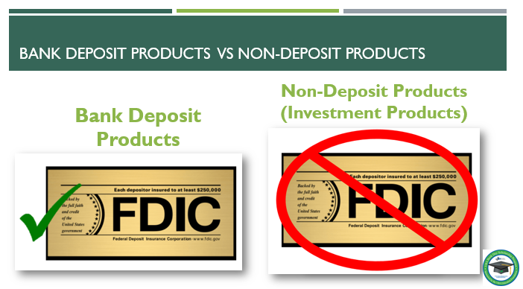

FDIC: Consumer Resource Center:
https://www.fdic.gov/resources/consumers/index.html
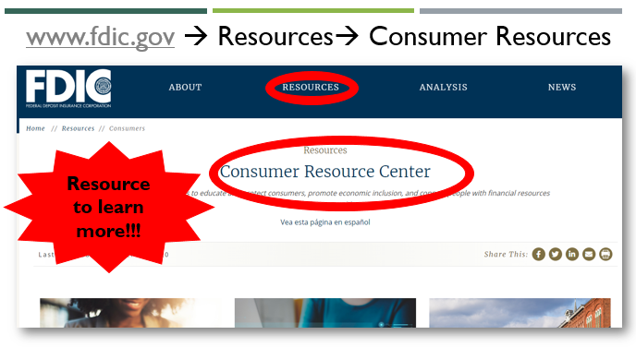
FDIC Notes:

- Create a BUDGET and stick to it! Don’t spend what you don’t make.
- Pay your bills ON TIME.
- Know what your BANK has to offer (online services, credit, savings options, etc)
- SAVE NOW! Always pay yourself first and work toward having a rainy day fund.
- Don’t be afraid to ASK. Ask your parents/banker about any financial questions you have.
- Don’t TRUST just anyone with your money. (Be aware of cash transfer apps like Venmo/Cash App—know who you are sending money to!)
- Use CREDIT wisely. If you can eat it or wear it, you shouldn’t use credit to purchase it. Begin building your credit history now and do it responsibly.
- Begin a RETIREMENT plan as soon as possible—there is no such thing as too early to save for your retirement.
- Beware of SOCIAL MEDIA! What you post never goes away. Employers might search for your social profiles and hackers might try to steal your identity using information you share online.

Financial Tips for College Students

