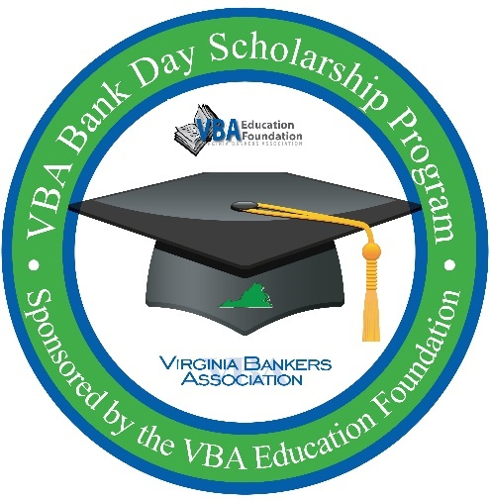
For Immediate Release

For More Information:
[Contact Name
Position
Bank
Contact Phone Number & Email]

[Bank Name] to Host High School Seniors for VBA Bank Day Scholarship Program:
Students Will Participate for a Chance to Win Up to $7,500 in College Scholarships

[City, VA (Date)] – On March [specific date], [bank name] will host high school seniors from [high school(s)] to participate in Bank Day, a statewide effort sponsored by the Virginia Bankers Association (VBA) Education Foundation and the VBA Emerging Bank Leaders. The purpose of the program is to expose students to the banking industry and provide an opportunity for the students to learn about banking, careers in banking, financial services and the vital role [bank name] and banks across Virginia play in their communities.

The third Tuesday in March was declared Bank Day by the Virginia General Assembly in 1991 and [bank name] is proud to host students for this important program. From their experience, participating students will write an essay for the chance to win a scholarship. Six regional scholarships of $2,500 each will be awarded by the VBA, and from those six winners a statewide runner-up and overall statewide winner will be chosen. The statewide runner-up winner will receive a total of $5,000 and the statewide winner will receive a total of $7,500. There will also be six honorable mention scholarships of $1,000 each. In all, twelve students statewide will receive scholarships totaling $28,500.

[As a Bank Day host, [[Bank Name]] will be hosting students [[in-person/virtually]] on X date for a Bank Day gathering as well as providing supplemental information to students about ways the bank supports the community (or any other details about other supplemental opportunities you will be offering the students).] Throughout the program, students will also have access to a Virginia banking industry resource website that houses videos, articles and podcasts to explore and research.

"Bank Day is one of the best short-term experiences for students—the opportunity to learn about the many services that banks offer and the ways Virginia banks support the communities they serve, and to start the networking that often leads to part-time and summer jobs, internships, and a start on a career path in the financial world,” said Bruce Whitehurst, president & CEO of the Mid-Atlantic Bankers Association and VBA.

[Optional quote from your bank’s leadership team.]

About [bank name]
[Information]

About the VBA Education Foundation
The Virginia Bankers Association Education Foundation was formed in 2007 with the objective of recognizing the importance of economic education and financial literacy in Virginia and supporting the banking industry as a key participant in these areas. Their mission is to advance personal financial literacy to students in all public and private schools across the Commonwealth. Learn more about the VBA Education Foundation here.

###

