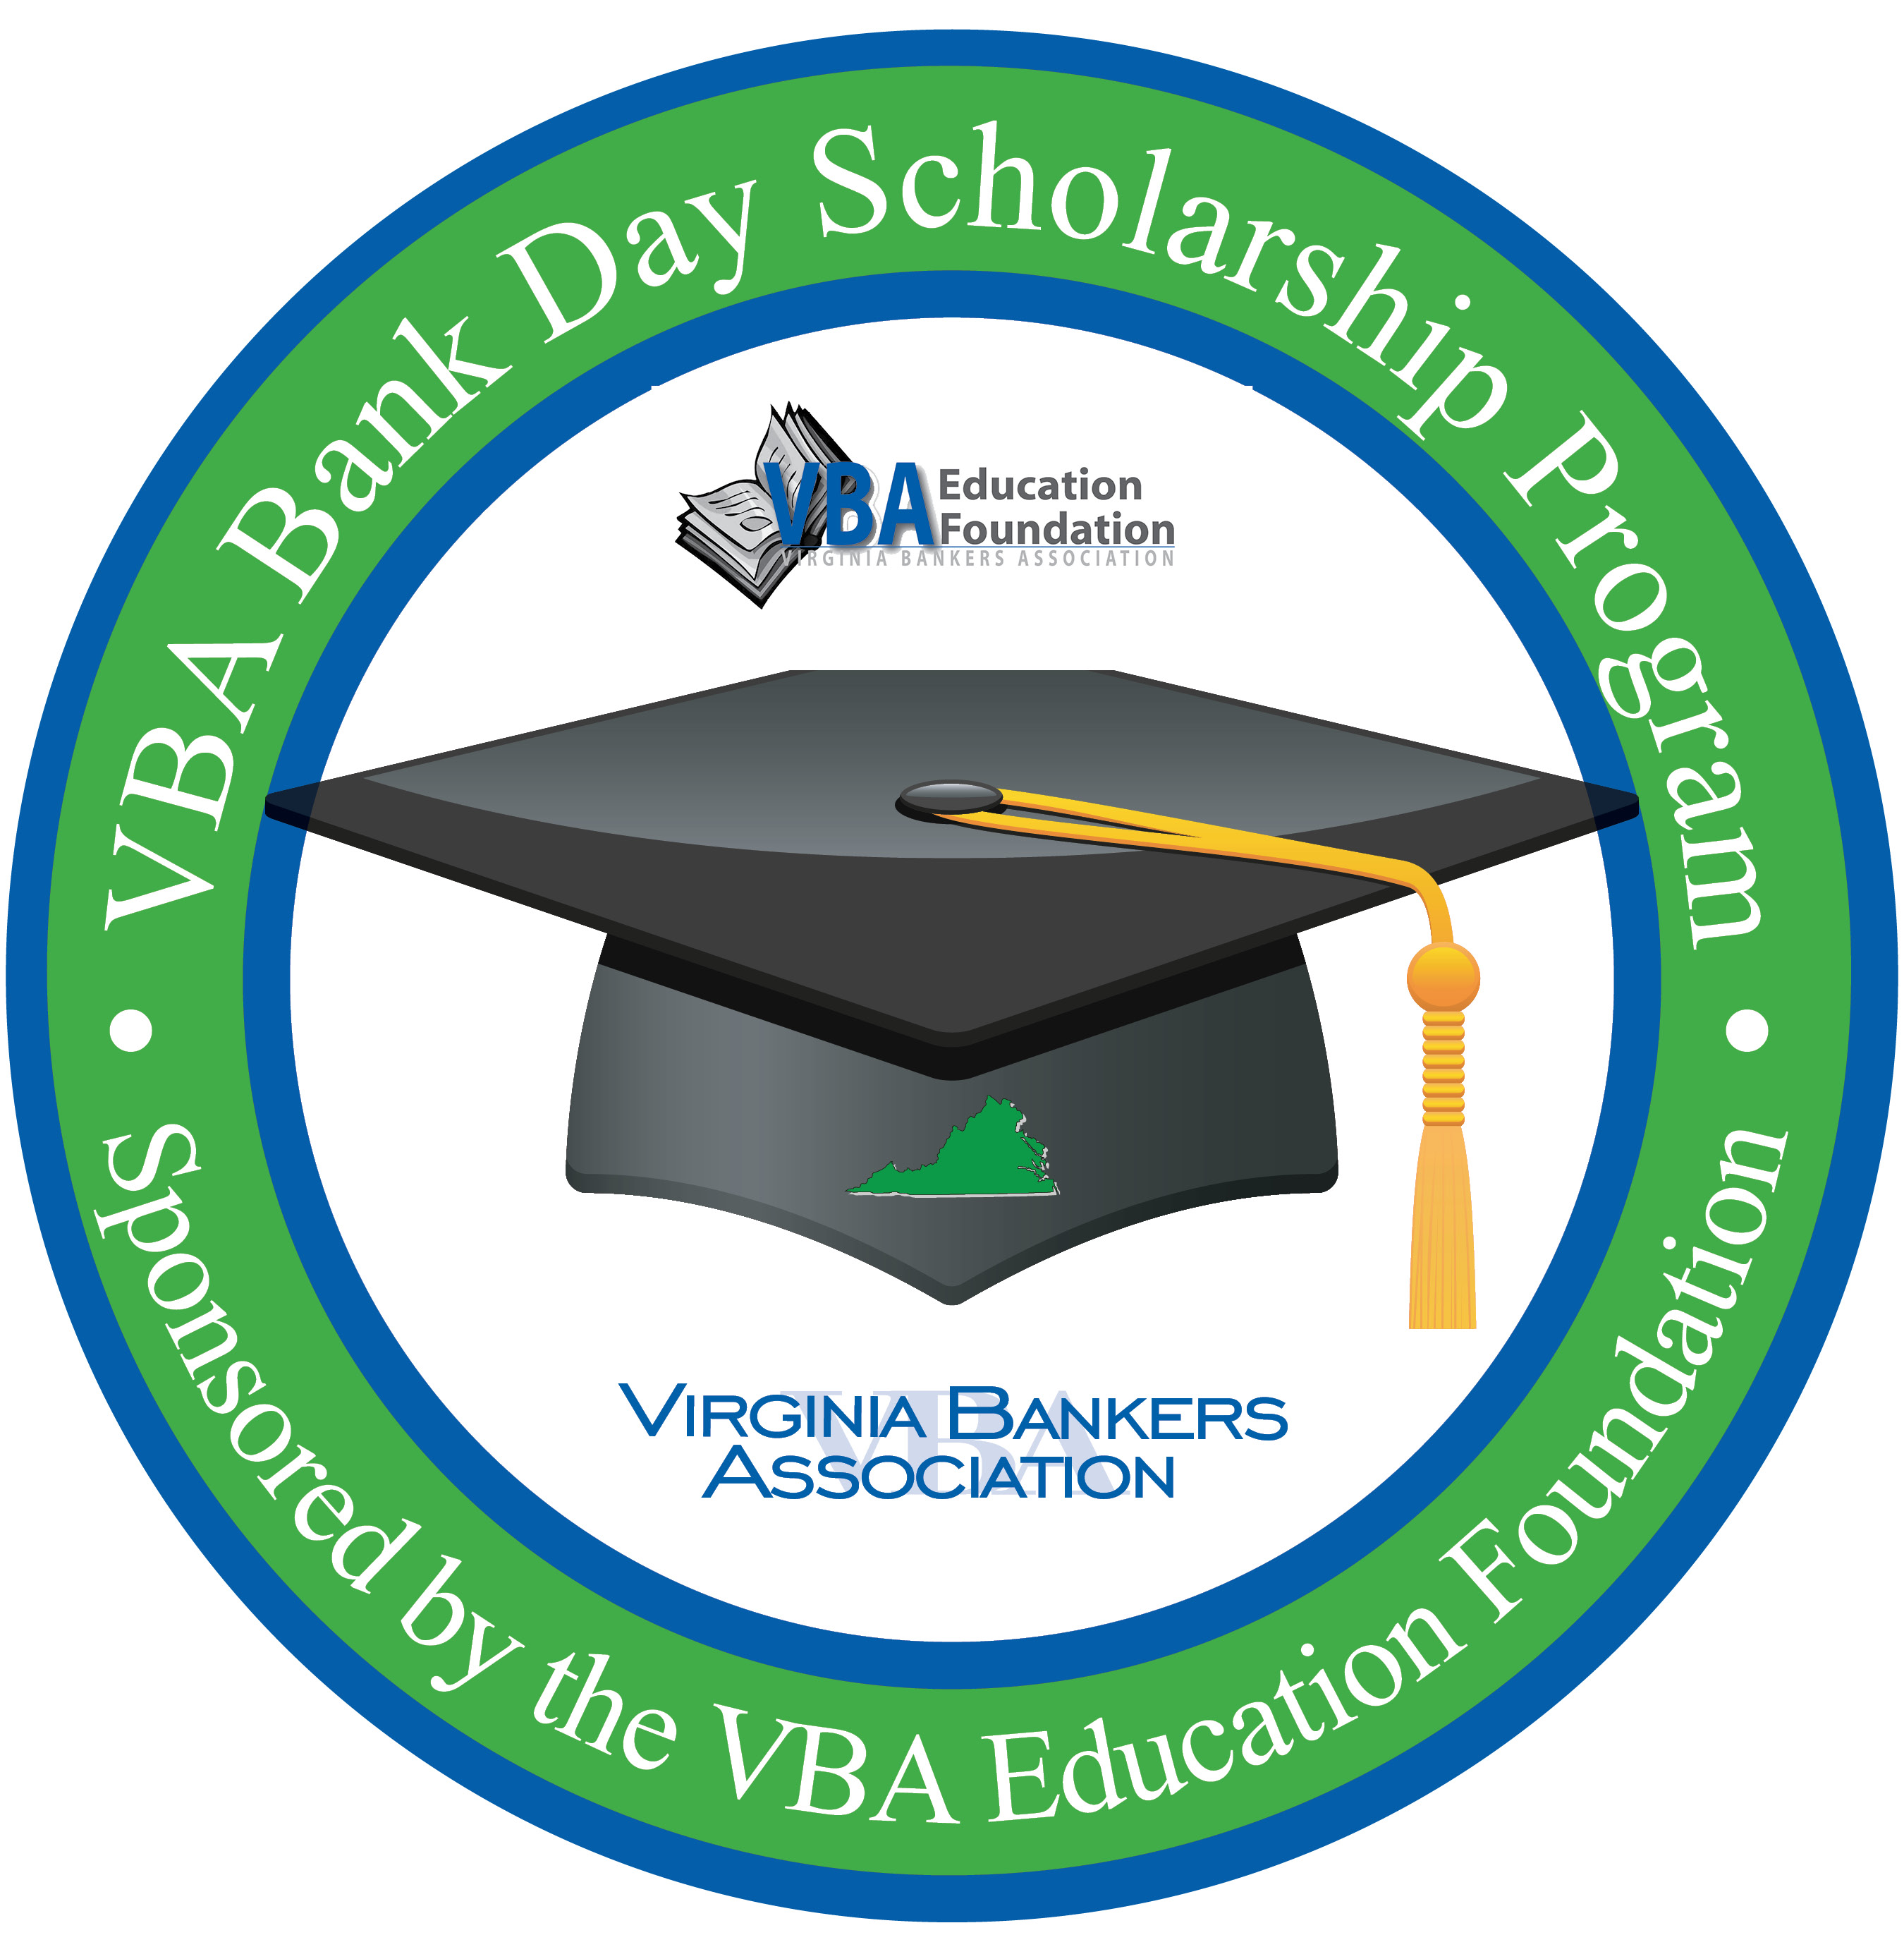
For Immediate Release

For More Information:
[Contact Name
Position
Bank
Contact Phone Number & Email]

[Bank Name] Participates in VBA Bank Day Scholarship Program:
Virginia High School Seniors Will Shadow Bankers for a Chance to
Win College Scholarship Money

[City, VA (Date)] – On March 17, Virginia high school seniors will spend the day shadowing bankers at [bank name] as part of Bank Day, a statewide effort sponsored by the Virginia Bankers Association (VBA) Education Foundation and the VBA Emerging Bank Leaders. The purpose of the day is to expose students to the banking industry and provide an opportunity for the students to learn about banking, financial services and the vital role [bank name] plays in its community.

The third Tuesday in March was declared Bank Day by the Virginia General Assembly in 1991 and [bank name] is proud to host students for this important program. From their experience, participating students will write an essay for the chance to win a scholarship. Six regional scholarships of $2,500 each will be awarded by the VBA, and from those six winners an overall statewide winner will be chosen. The statewide winner will receive an additional $5,000 scholarship - $7,500 in total. There will also be six honorable mention scholarships of $1,000 each. In all, twelve students statewide will receive scholarships totaling $26,000.

During their visit, the students will [visit various bank departments; learn about the loan process, the importance of good credit, the profile of a qualified borrower, appropriate etiquette during a job interview, how [bank name] is involved in the community, payments, etc.].
"Bank Day is one of the best short-term, hands-on experiences for students—the opportunity to go inside the bank vault, to watch customer/bank officer interaction, to learn about the many services that banks offer, and to start the networking that often leads to part-time and summer jobs, scholarships, and a start on a career path in the financial world,” said Bruce Whitehurst, president & CEO of the Virginia Bankers Association.

[Optional quote from your bank’s President.]

About [bank name]
[Information]

About the VBA Education Foundation
The Virginia Bankers Association Education Foundation was formed in 2007 with the objective of recognizing the importance of economic education and financial literacy in Virginia and supporting the banking industry as a key participant in these areas. Their mission is to advance personal financial literacy to students in all public and private schools across the Commonwealth. Learn more about the VBA Education Foundation here.

###

