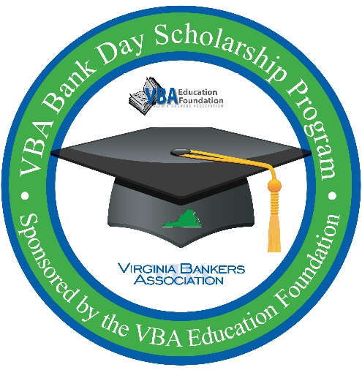**MEDIA ADVISORY**

**[Date]**

**For More Information:**

[**Contact Name**

**Position   
Bank**

**Contact Phone Number & Email**]

**[Bank Name] to Host High School Seniors for VBA Bank Day Scholarship Program:**

**Students Will Participate for a Chance to Win Up to $7,500 in College Scholarships**

**WHO:** High school students from **[high school name(s)]** and bankers from **[bank name]**

**WHAT: [Bank name]** will host high school seniors to participate in the Virginia Bankers Association (VBA) Bank Day Scholarship Program, learning about the banking industry and ways to manage their financial future. Through this statewide initiative, a total of $28,500 in scholarships will be awarded to twelve Virginia high school seniors from the VBA Education Foundation.

**WHEN:** Students will participate in this program in March 2025.

**WHERE: [City/County]**

**For more information, please contact [banker name] at [email address] or [phone number].**

In March, Virginia high school seniors will participate in the VBA Bank Day Scholarship Program, sponsored by the Virginia Bankers Association Education Foundation. Through this program, students learn about banking, financial services, career opportunities and the vital role banks play in their communities.

The third Tuesday in March was declared Bank Day by the Virginia General Assembly in 1991 and [**bank name**] is proud to host students for this important program. From their experience, participating students will write an essay for the chance to win a scholarship. In all, twelve students statewide will receive scholarships totaling $28,500.

**[As a Bank Day host, [[Bank Name]] will also be hosting students for an [[in-person/virtual]] gathering on [[X date]] and providing supplemental information to students about ways we support the community we serve (or any other details about other opportunities you will be offering the students).]**

***About [Bank Name]***

***[Information]***

***About the VBA Education Foundation***

*The Virginia Bankers Association Education Foundation was formed in 2007 with the objective of recognizing the importance of economic education and financial literacy in Virginia and supporting the banking industry as a key participant in these areas. Their mission is to advance personal financial literacy to students in all public and private schools across the Commonwealth. Learn more about the VBA Education Foundation* [*here*](https://www.vabankers.org/education-foundation)*.*

###