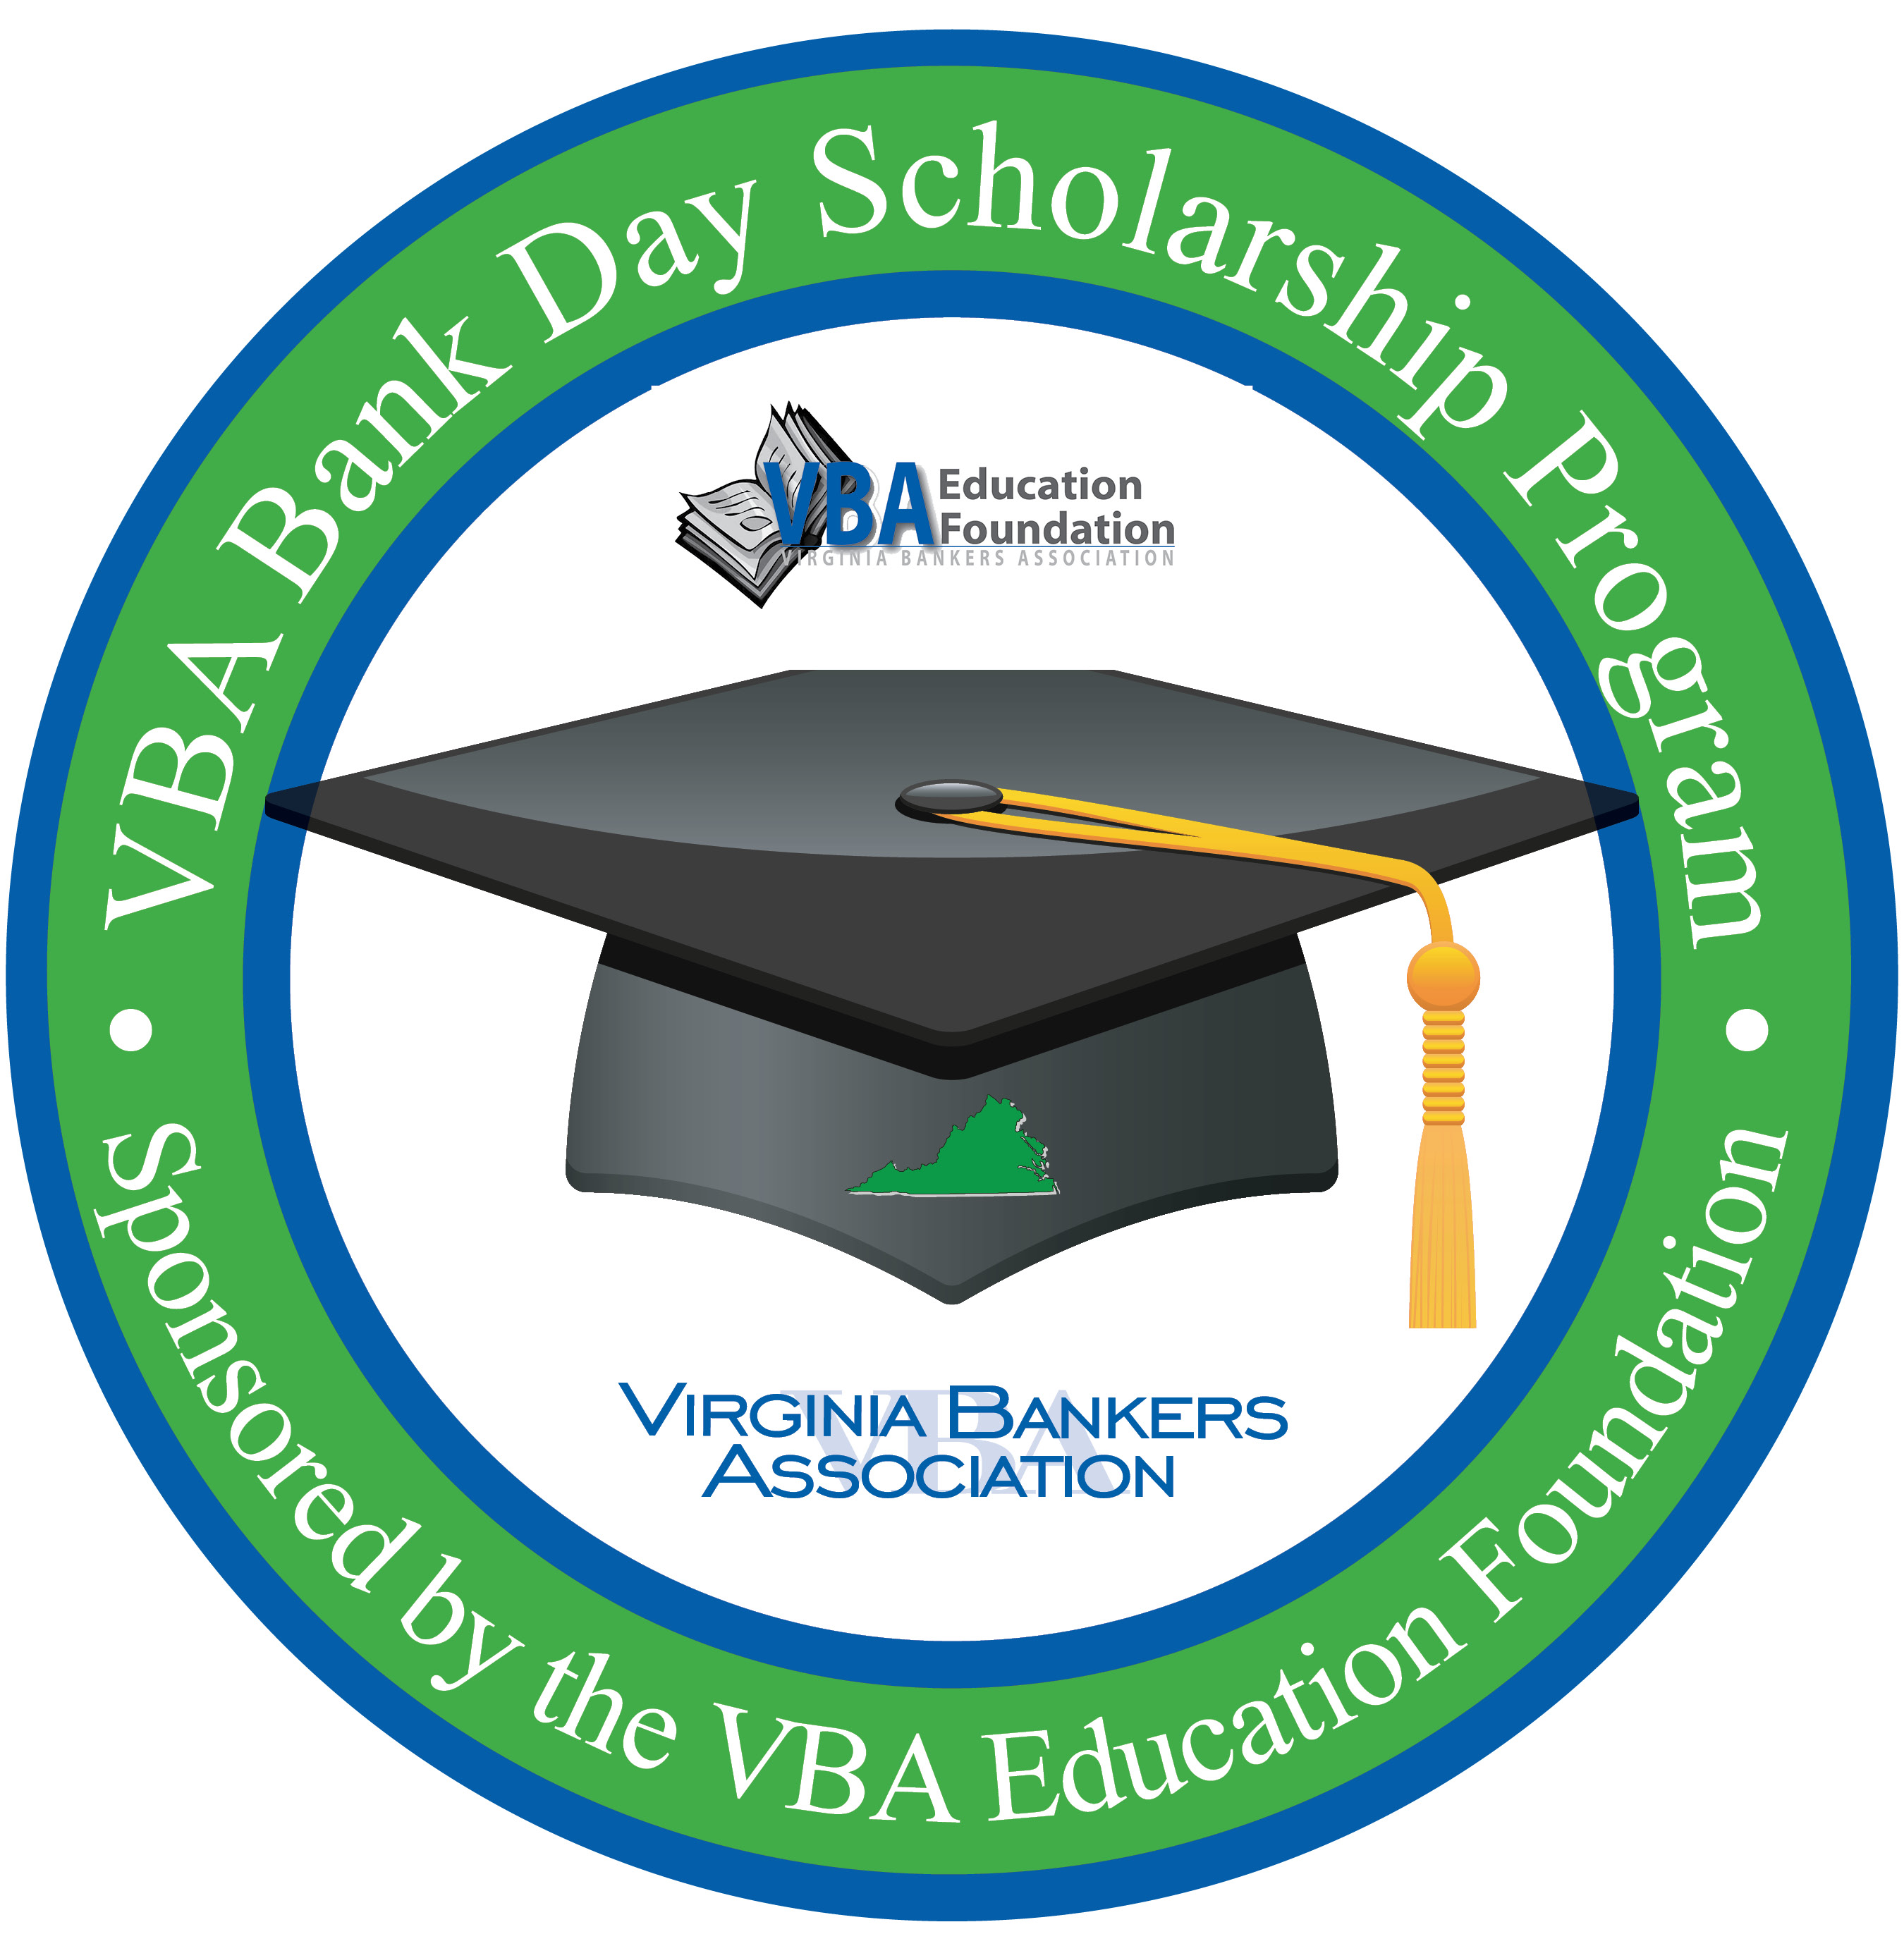
MEDIA ADVISORY
[Date]

For More Information:
[Contact Name
Position
Bank
Contact Phone Number & Email]

[Bank Name] to Participate in VBA Bank Day Scholarship Program:
Virginia High School Seniors Will Shadow Bankers for a Chance to
Win College Scholarship Money

WHO: High school students from [high school name(s) or counties] and bankers from [bank name]

WHAT: High school seniors will participate in the VBA Bank Day Scholarship Program at [bank name], spending the day shadowing bankers and learning about the banking industry and ways to manage their financial future. A total of $26,000 in scholarships will be awarded to twelve Virginia high school seniors.

WHEN: [March 17, 2020]

WHERE: [Details about your Bank Day location(s)]

To attend, please contact [banker name] at [email address] or [phone number].

In March, Virginia high school seniors are leaving the classroom for the branches of banks in their community to participate in the VBA Bank Day Scholarship Program, sponsored by the Virginia Bankers Association Education Foundation.

During their visit, the students will [visit various bank departments; learn about the loan process, the importance of good credit, the profile of a qualified borrower, appropriate etiquette during a job interview, how [bank name] is involved in the community, payments, etc.].

The third Tuesday in March was declared Bank Day by the Virginia General Assembly in 1991 and [bank name] is proud to host students for this important program. From their experience, participating students will write an essay for the chance to win a scholarship. In all, twelve students statewide will receive scholarships totaling $26,000.
About [bank name]
[Information]

About the VBA Education Foundation
The Virginia Bankers Association Education Foundation was formed in 2007 with the objective of recognizing the importance of economic education and financial literacy in Virginia and supporting the banking industry as a key participant in these areas. Their mission is to advance personal financial literacy to students in all public and private schools across the Commonwealth. Learn more about the VBA Education Foundation here.

###

