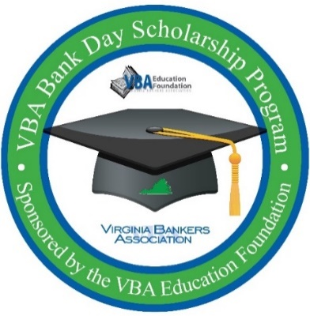
VBA Bank Day Scholarship Program

This letter confirms that ____________________________ (student name) from __________________________________ (High School) was in attendance for the VBA Bank Day Scholarship Program at (bank name) on ______________ (date) from ________ a.m. to ________ a.m./p.m.

Please contact me with any questions.
Banker Name/email address

