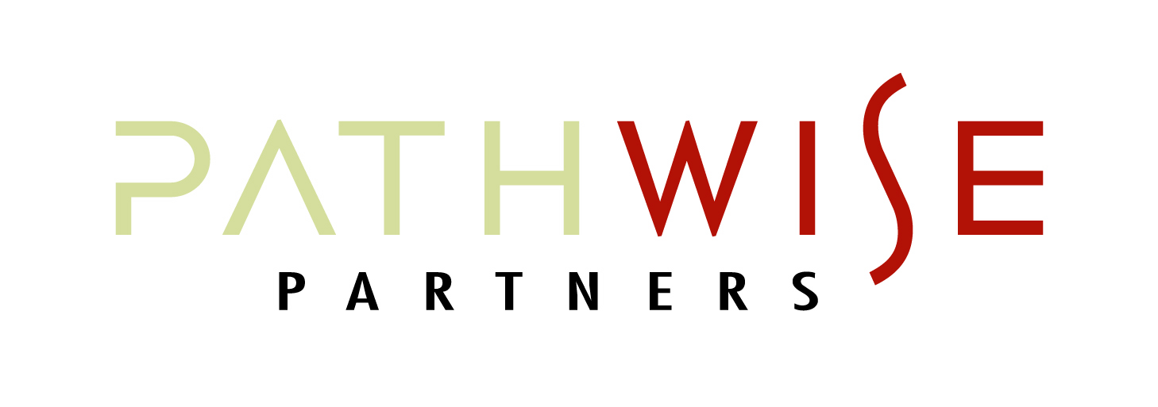
“DIRECT” Communication

Prepare for productive conversations by using this “DIRECT” communication guide:

Determine your objectives and desired outcomes (and roles for participation) for the communication/conversation. Also determine the best venue/location. | - Objectives:  - Desired Outcomes:  - Best Location/Venue:  - Expectations (listen/decision/solution):
Introduce context and the purpose of the communication/feedback from your perspective – along with any anxieties/fears you may have… | - Context:  - Purpose:  - Anxieties/Fears:
Remember to focus on the facts involved in the situation, remove the “wrong” from the conversation and consider “their world.” Be free of assumptions when you enter the conversation. | - Facts:  - Assumptions you have made (to dismiss prior):
Engage the participant and ask what they have heard from you (remember the level of listening likely to occur). Resist the temptation to “predict” how the conversation will go. | - Determine key points in the conversation to “check-in”:
Consider your relationship with those in the conversation – and speak in the context of your commitment to their development and their (your collective) success. | - Consider your relationship (A – F):  - State your commitment to:
Take the time to provide feedback – and remember, important conversations typically don’t take as much time as you might imagine. Be prepared to “hang” in the conversation until you are satisfied that the communication is complete and that your objectives have been met. We often leave a little too early…and then need to return to the difficult (incomplete) conversation. | - Determine/set the time:  - Identify what’s required for you to be complete:

