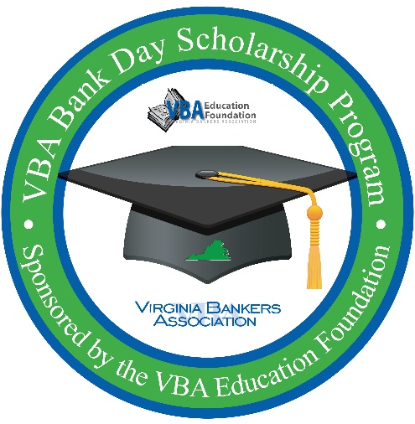
Subject: Give Your Seniors a Chance to Win Up to $7,500 in Scholarships!

Dear [Name],
We’re excited to share an incredible opportunity for your seniors: Bank Day, a statewide scholarship program sponsored by the Virginia Bankers Association Education Foundation (VBA) and hosted locally by [Bank Name].
What is Bank Day?
The Virginia General Assembly declared the third Tuesday in March as Bank Day back in 1991. This program gives high school seniors a behind-the-scenes look at banking, financial services, and career paths—while showing how banks strengthen their communities.
After participating, students write an essay about what they learned. Fourteen scholarships totaling $28,500 will be awarded based on these essays!
Scholarship Breakdown:
- 6 Honorable Mentions: $1,000 each
- 6 Regional Winners: $2,500 each
- Statewide Runner-Up: $5,000 total
- Statewide Winner: $7,500 total
How It Works:
- Students must be Virginia high school seniors with a 3.0+ GPA.
- Register online by February 27: https://forms.office.com/r/R6U1nbwcv6
- [Bank Name] will host students on [Date] during the school day for an interactive session about banking and community impact. Student attendance is required for scholarship eligibility.
Students will also receive access to VBA’s Bank Day Resource Webpage in March to help them prepare their essays.
Why Encourage Your Seniors?
This program is more than a scholarship—it’s a chance to:
- Learn real-world financial skills
- Explore banking careers
- Earn money for college
Please see the attached flyer for details. More details about this gathering will be shared with students upon registration.
I’d love to connect and make sure students from [School Name] don’t miss out! Thank you for supporting your students’ success.

Best regards,
[Name]
[Title]
[Bank Name]
[Contact Information]
[Bank Logo]

