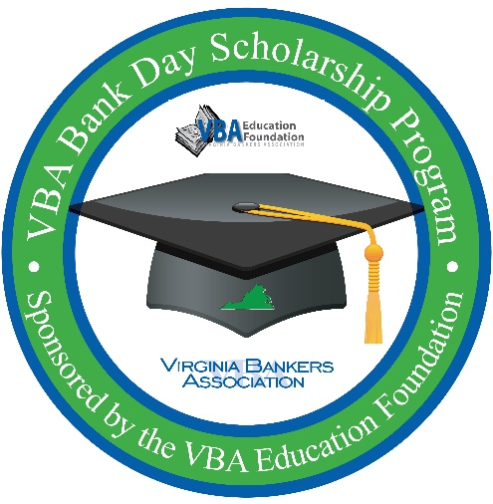
Subject: Two Weeks Left! Encourage Your Seniors to Register for Bank Day

Dear [Name],
Just a quick reminder—there are only two weeks left for your seniors to register for the Virginia Bankers Association Bank Day Scholarship Program!
This unique opportunity gives students a behind-the-scenes look at banking and financial services while competing for college scholarships.
Key Details:
- Registration Deadline: February 27
- Eligibility: Virginia high school seniors with a 3.0+ GPA
- Event Date: [Bank Name] will host students on [Date] during the school day (attendance required for scholarship eligibility).
- Scholarships: Up to $7,500 for the statewide winner!
Students can register here: https://forms.office.com/r/R6U1nbwcv6 by February 27.
Please share this with your seniors today so they don’t miss out. Attached is a flyer with all the details.
Thank you for helping us connect students with this incredible opportunity!
Best regards,
[Name]
[Title]
[Bank Name]
[Contact Information]
[Bank Logo]

