Ethical Decision-Making

Virginia Bankers Association
2022 School of Bank Management
Charlottesville, VA

Richard Coughlan
University of Richmond
Richmond Business Consultants

Ethical Decision-Making Module
2022 School of Bank Management

Every day at work you make dozens of decisions, many of which have become routine for you. As you gain more experience in the banking industry and in a given role, it is normally the case that your choices lead you and others to experience reasonably good outcomes. This would be an indication that your decision-making process is suitable for most purposes.

Occasionally, however, a new opportunity or an unexpected roadblock forces you to develop new ways to approach a decision. Maybe your top candidate decided to take a job elsewhere and you have to decide whether to delay the search or “settle” for the second-best option. Perhaps your bank is interested in launching a new product offering or looking to compete in a new geographic territory. In these instances, you would probably need to devote much more attention to the processes that lead to the decisions you make.

This module is designed to have you explore your decision-making processes in detail and look for areas of improvement. During our time together, we will discuss how you gather, organize and use information while identifying and comparing various options and while making tough choices at work.

An important part of our conversation will be the recognition that positive outcomes are more likely when an individual has developed and honed a process that centers on values. Adherence to values (our own and those of our bank) can be challenging, especially if we are unclear about the criteria that should guide us. This is sometimes the case in an organizational setting and one of the reasons that accountability becomes an important feature in a company’s culture.

In our sessions this week, we will also explore the decision-making processes of groups, highlighting the mixed motives of collaboration and competition that exist in many organizations. We will touch on cultural factors that can have an impact on the effectiveness of group decision-making and that occasionally lead to unethical decisions. Finally, I will also provide opportunities for you to review common dilemmas among leaders in the banking industry.

- Major course objectives are bolded and underlined above

In the space below, describe the worst decision you have made in 2022.

The decision can be drawn from work or from your life away from work. However, it must meet these three criteria:
- It was your decision.
- The decision is behind you; you decided on some particular course of action.
- The outcome of the decision is now known.

PLEASE WRITE A BRIEF DESCRIPTION OF THE WORST DECISION YOU HAVE MADE THIS YEAR:

WHY DO YOU CONSIDER THIS TO BE AMONG YOUR WORST DECISIONS OF 2022?

Course Outline

- Introductions and overview of course

- Distinguishing process and outcome
- What can I control? How do I raise the likelihood of positive outcomes?

- The rational decision-making model
- What is the appropriate sequence of steps toward rendering a choice?

- The values-based model
- Is there a place for values in a model that is “rational”?

- An introduction to ethical decision-making: relativism & idealism
- How might my standards of right and wrong vary by situation?

- Right-vs-Right dilemmas
- Toughest choices involve two or more justifiable alternatives

- Resolving dilemmas: values, duties, and consequences
- Forecast what will happen or reflect on my obligations?

- Applying values to real-life dilemmas
- Honor truth or display loyalty? Show mercy or dole out justice?

- Building and sustaining an ethical culture
- The 4C framework

- The role of accountability in actions and decisions
- How feelings of accountability shape behavior at work

The Rational Decision-Making Model

- Identify a decision opportunity

- Search for alternatives

- Establish decision criteria (including “weights” or priorities)

- Evaluate each of the alternatives according to the criteria

- Make choice (alternative with highest value) and implement

QUESTIONS FOR YOU TO CONSIDER IN SMALL GROUPS

Is this model a good way to arrive at a choice that will lead to good outcomes?

Does it resemble the model you probably use for resolving most decision opportunities, at work and away from work?

In what ways does being a member of a team or an organization make following this model easier or more difficult?

What is not in the model that should be?

A Values-Based Decision-Making Model

(same steps, different order)

- Identify a decision opportunity

- Search for alternatives

- Establish decision criteria (including “weights” or priorities)

- Evaluate each of the alternatives according to the criteria

- Make choice (alternative with highest value) and implement

Main question:

Will the choice you make in step 5 be any different than what you would have made via the original process?

Other questions:

In what ways is this model better than the original model?

Does it seem to be a reasonable method for resolving most decision opportunities?

In what ways does being a member of a team or an organization make following this model easier or more difficult?

Ethics Questionnaire

Please read each statement carefully. Indicate the extent to which you agree or disagree with each statement using a scale from 1 to 9 where:

1 = Completely Disagree
5 = Neither Agree Nor Disagree
9 = Completely Agree

*Note: you may use any value from 1 to 9 for each response

1. If an action could harm an innocent individual, then it should not be done.

2. Deciding whether or not to perform an act by balancing its positive consequences against its negative consequences is immoral.

3. A person should make certain that his or her actions never intentionally harm another, even to a small degree.

4. One should never psychologically or physically harm another person.

5. The dignity and well-being of people should be the most important concern in any society.

6. Questions of what is ethical for everyone can never be resolved, since what is moral or immoral is up to the individual.

7. Ethical guidelines for interpersonal relations are so complex that individuals should be allowed to formulate their own codes for such situations.

8. Whether a lie is permissible or not permissible depends entirely on the situation.

9. Moral standards are simply personal rules indicating how one should behave, and it is not appropriate to apply them in making judgments about others.

10. What is ethical varies from one situation to another.

Right-versus-Right Dilemmas

Many of the actions that are described as unethical (such as financial fraud, employment discrimination, embezzlement, etc.) are just plain illegal. There is not much of a dilemma preceding the decision to act illegally. For those of us who study decision making, these scenarios are not all that interesting.

In Rush Kidder’s book, How Good People Make Tough Choices, the author encourages his readers to spend time thinking through the most difficult ethical dilemmas. He suggests that the hardest challenges for leaders, managers and employees are situations where two or more justifiable alternatives exist.

In other words, it would be “right” to choose alternative A and it would be “right” to choose alternative B (although probably for a different reason).

According to Kidder, there are four categories of right-versus-right dilemmas:

Truth versus Loyalty

Justice versus Mercy

Individual (or small group) versus Community (or large group)

Long-term versus Short-term

On the pages that follow, describe a real-life dilemma from each of the four categories listed above.

Truth versus Loyalty

Provide a general description of the scenario:

What is the truth?

What option does the truth suggest you ought to pursue?

Why is it “right” in this instance to pursue the option that honors the truth?

Where are your loyalties?

What option do those loyalties suggest you ought to pursue?

Why is it “right” in this instance to pursue the option that displays loyalty?

Loyalty
Think of the 2-3 most loyal individuals in your workplace.

What characteristics do they share?

If I observed your workplace for a month, would their level of loyalty be evident to me?

What would I see and hear from them that might be distinct from what I would see and hear from other employees?

Justice versus Mercy

Provide a general description of a justice vs mercy scenario you have faced:

What is just (or fair) in this scenario?

What option does justice suggest you ought to pursue?

Why is it “right” in this instance to pursue the option that honors justice?

What is mercy is this scenario?

What option does mercy suggest you ought to pursue?

Why is it “right” in this instance to pursue the option that honors mercy?

Individual versus Community

Provide a general description of an individual vs community dilemma you have faced:

What would be in the best interest of the individual?

What option should you pursue in order to address the needs of the individual?

Why is it “right” to choose the option that benefits the individual?

What would be in the best interest of the community?

What option should you pursue in order to address the needs of the community?

Why is it “right” to choose the option that benefits the community?

Short-term versus Long-term

Provide a general description of the scenario:

What is the potential short-term gain?

What option should you pursue in order to achieve the short-term gain?

Why is it “right” to choose the option that yields a short-term gain?

What is the potential long-term gain?

What option should you pursue in order to achieve the long-term gain?

Why is it “right” to choose the option that yields a long-term gain?

What are the benefits of Kidder’s taxonomy?

- Allows us to more easily recognize the type of dilemma we’re facing

- Presents an opportunity to reflect on problem-solving strategies* that have been successful in the past with similar dilemmas

- If applied consistently, the taxonomy leads us to realize just how many perceived dilemmas are not really dilemmas at all

*NOTE: Kidder’s taxonomy is more about recognizing and categorizing dilemmas than it is about resolving dilemmas.

Resolving ethical dilemmas

- Results-based approaches

This approach is based on the idea that the “best” alternative is the one that leads to the greatest good (or the smallest amount of harm).

Here, the decision-maker starts by identifying the primary stakeholders. Think of a stakeholder as an individual or group that has an impact on or that is impacted by the decisions you make. Your group of stakeholders might vary slightly from dilemma to dilemma. With this in mind, create a list of stakeholders for the current decision scenario. Then, consider how each stakeholder would be impacted by the various options you could pursue.

- Duty-based approach

This approach centers on the idea that resolving dilemmas is about recognizing and fulfilling the duties (or obligations) we have as employees/decision-makers. These obligations arise from the various roles we play at work and elsewhere and from our concept of what is right and appropriate.

So, when we follow a duty-based approach, the focus is on “doing the right thing” where right is a function of our beliefs about what someone like us should do in a given situation. Consequences are not part of the equation in this approach.

- Values-based approach

As noted earlier, one possibility for resolving decisions (in general) is to specify values prior to searching for alternatives. This approach can also be applied to ethical dilemmas we encounter.

One of the major questions related to the values-based approach is what set of values ought to guide the decision. Some firms have articulated their shared values.

For example, here are the values of First Republic, a large bank that operates primarily in California, New York and Florida:

• Do the Right Thing
We strive to do things right at First Republic. We also recognize that we're a business of humans; mistakes will happen. Therefore, our mandate is to do the right thing: act with integrity, own your actions, correct mistakes, learn from experience.

• Provide Extraordinary Service
We always aim to exceed expectations and serve our clients in unexpected ways. We'll take on only what we can do right. Our business may be about wealth management and banking, but our success is all about service—exceptional customer service.

• Respect the Team
Everyone at First Republic makes a difference and everyone at First Republic deserves to feel that his or her contribution is valued. We place high value on collaboration because we know that the power of many is greater than the power of one.

• Take Responsibility
At First Republic, it's not enough to do our own jobs well. Making sure our clients are satisfied is everyone's job. So if something needs fixing, we step up to the plate, "own" the problem and make things right.

• Think Positively
We operate in an environment of trust and encourage openness and flexibility. We hire positive people who act positively. Our goal is to "manage toward yes."

• Move Forward, Move Fast
There are two types of organizations—organizations that spend time checking and organizations that spend time doing. We're doers. We value action and decisiveness and recognize that the best opportunities come to those that act quickly.

• Grow
We've evolved greatly since our inception, expanding ourselves and our business purpose. At First Republic, we embrace change and every person has the opportunity to grow and contribute. We want our people to soar.

• Have Fun
We know that if everyone enjoys their work they'll do a better job—and our clients will feel the difference. It's really that simple
SMALL GROUP QUESTIONS

How do you believe these values would be helpful in guiding specific decisions faced by employees of First Republic?

Can you identify tension between two of the values? How might that tension show up in decision-making?

How do these values compare to the values of your bank?

Improving alignment of values – The Four C’s
CULTURE
Notes:

CODE
Notes:

COMMUNICATION
Notes:

COMPENSATION
Notes:

Accountability

An expectation that your decisions, actions or outcomes will be evaluated by some relevant audience with the belief that there is potential to receive rewards or sanctions based on the evaluation.

More about mindset, not monitoring

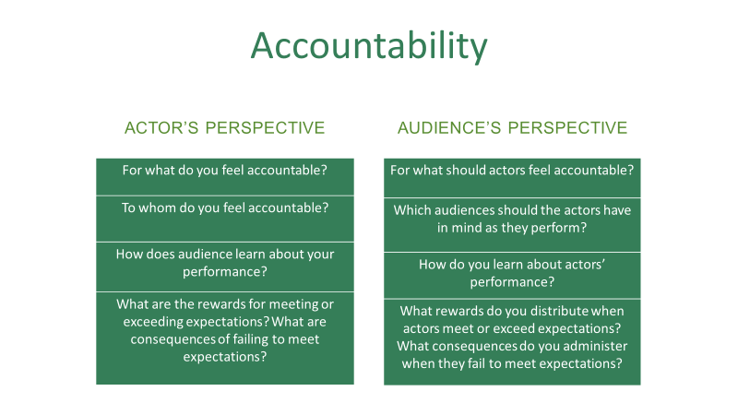

Please offer brief responses to the following questions below:

To whom do you feel accountable?

For what do you feel accountable?

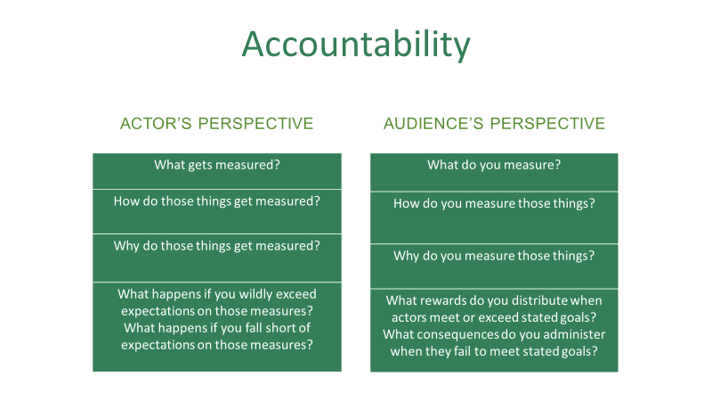

Identify one thing that is explicitly measured at your bank that, in your opinion, does not need to be measured. (Often, eliminating this kind of measure actually improves performance, efficiency and/or morale!)

Now, identify one thing that is not measured that ought to be.

What do your answers suggest about the current culture of accountability at your bank?

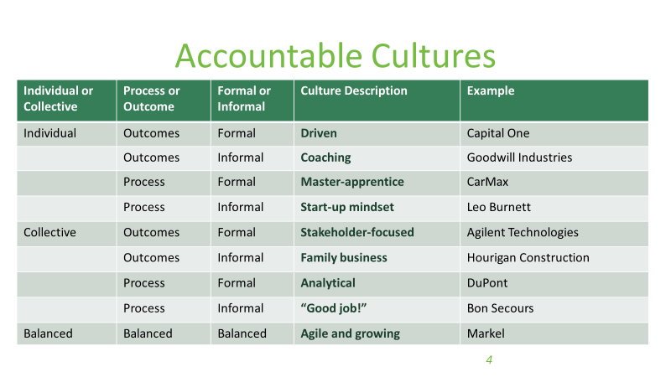

Which of these categories best fits the culture of your bank? Explain.

For the last six months, you have been representing your branch as part of a company-wide strategic planning team at the bank. During the last three meetings of the group, conversation has focused on the consolidation of the bank’s branches in central Virginia.

It now appears likely that your branch will remain open but that a nearby branch will close. The bank hopes to hold on to a few of the key employees from that branch, but at least a dozen individuals will be without a job. Although the decision has been made, the leaders of the bank have indicated that no announcement will be made until after Labor Day.

One of your former college classmates, who plays on the company softball team with you, has been working since 2008 in the branch that will close. Just before last week’s softball game, he asked if you knew any specifics about the possible consolidation. He also mentioned that he and his wife had spent the previous weekend looking for their first house as they had tired of paying rent, especially with the attractive housing prices here.

- What are your options (specifically) for responding to your friend?

- How should you respond to your friend?

- How would you respond to your friend?

- What values would guide your choice in this scenario?

Joanne is a branch manager who is responsible for the supervision of eight employees. One of her employees, Don, has worked at the bank as a teller for three years. Joanne knows that Don has had a difficult year in his personal life. He has been open with her about the problems at home, especially as it began to affect his work at the bank. For the first time since he started with the bank, his performance has been below expectations.

The annual performance review is scheduled for next week. Joanne is doing her initial preparation for the meeting with Don. Among other things, she needs to fill out the company-mandated performance evaluation form. It includes eleven questions about Don’s performance this year. In each of his first two years, Don received “above average” ratings for more than 80% of the items on the form.

Joanne is confident that Don’s performance will be better in the coming year as he moves beyond his recent personal problems.

- To what extent should Joanne take into account Don’s personal problems when filling out the performance evaluation form?

- What values should guide her decision about conducting these performance reviews?

You have recently taken over responsibility for monitoring your bank’s lending facilities to a start-up company. Its sole activity to date has been developing an innovative type of valve for heat pumps. The majority shareholder is a university professor who patented the product personally but has formally transferred all rights and royalties to the company.

There has been some interest in purchasing these rights but the professor has flatly refused all offers, even though the company itself has made no sales. The company’s only other significant asset is an unexpired nine-year lease for a factory premises on a popular industrial site.

The problem you face is that, while the company’s authorized overdraft is adequately covered by the security that the bank holds over the factory premises and the patents, your predecessor had, through a bureaucratic error, allowed the company to exceed its overdraft limit by $70,000. Your charge is to terminate the banking relationship and recover as much as possible of the authorized overdraft.

At the start of the meeting at which you intend to inform the professor of the new arrangement, you discover that he has just raised $35,000 through private borrowing from relatives. He has also found a faculty colleague who is willing to invest $30,000. All of the funds will be paid to the company tomorrow. In return, the company will issue shares to the other professor and the relatives.

None of the new investors are aware that their investments will simply reduce the amount borrowed to approximately the authorized overdraft level but will not provide any new operating funds.

Is it ethical to wait to inform the professor of the bank’s termination of his lending facility until after the new investment of $65,000 has reduced the overdraft amount?

You are senior client manager for an important corporate customer. The customer has consistently divided its extensive banking needs between your bank and a competitor for many years, despite your best efforts to gain a preferred status.

A month ago, your bank and your competitor were invited to submit a bid for the full banking relationship of this customer. You and a small team devoted a great deal of time and energy to deliver a detailed presentation document to the customer last week. It would serve as the basis for the customer’s decision about which bank would be awarded the exclusive contract.

Three days ago, the customer informed you that both banks were judged to be equally capable in terms of product range, service quality and relationship management. The bids were marginally different on price and the customer has asked you to make any pricing revisions you consider appropriate before a final decision is made. The revisions must be made by tomorrow afternoon and the customer has promised that will be the end of the decision process.

It is 7pm and your boss has just left for dinner and a concert, having expressed some frustration that you were unable to win the business outright the first time around. Before leaving, your boss indicated that the bank would rely on you to make whatever revisions you thought appropriate.

A colleague rushes in with great excitement. She just received a phone call from Jeffrey, a senior member of the customer’s decision-making team. He told her that your competitor had just submitted its bid. He is offering to fax it over to you in exchange for your bank serving as a sponsor ($10,000) for a charity that benefits children with a particular disability.

You know that Jeffrey’s son suffers from this disability and do not think that arranging the sponsorship would present you with a problem. Payment to the charity could be arranged by you with the support of a senior colleague (and friend) in the bank.

How do you respond?

