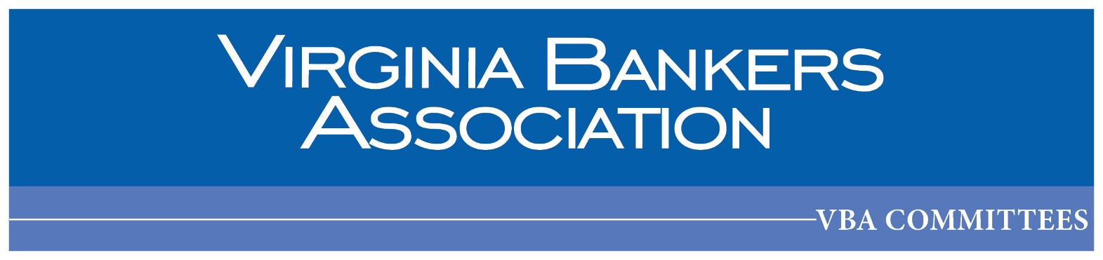

**Agenda**

VBA Security & ERM Committee Meeting

May 15, 2025 | 11:00 a.m. – 12:00 p.m.

VBA Headquarters | Capital Room

Security & Enterprise Risk Management Committee Mission Statement

*Promote the sharing of security and enterprise risk management best practices within the Virginia banking community. Provide peer networking opportunities, industry insights and expertise to assist members in remaining at the forefront of security and enterprise risk management advancements.*

1. Welcome
2. VBA Virtual – online training opportunities for security and risk
3. Connect|Protect Experience Committee Survey Discussion
4. Roundtable Exercise – Current Hot Topics & New/Noteworthy Vendors
5. Adjourn

[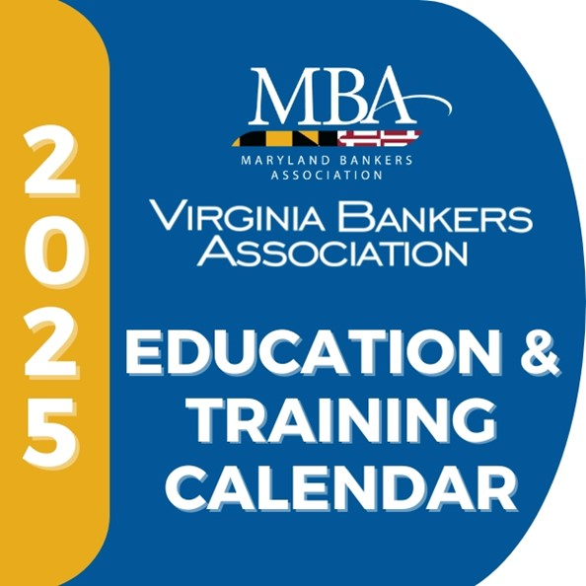](https://www.vabankers.org/event-calendar)[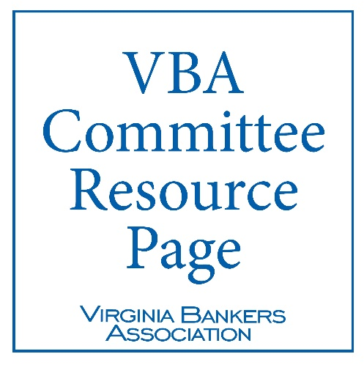](https://www.vabankers.org/internal-links/vba-committees-resource-page)[](https://www.vabankers.org/post/2025-connectprotect-experience-recap)

[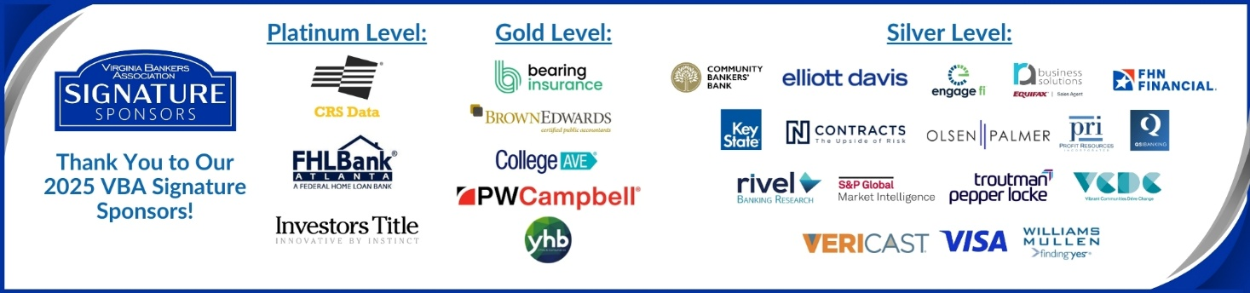](https://www.vabankers.org/vba-signature-sponsors)