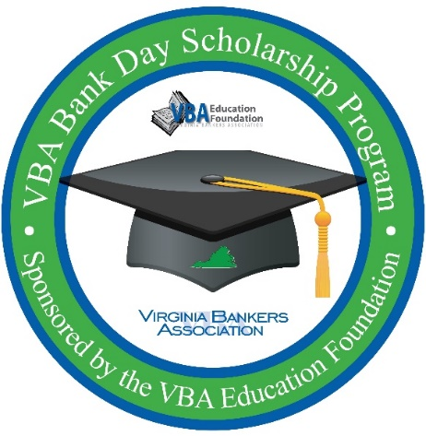
VBA Bank Day Scholarship Program
Student confirmation email template

Things to consider attaching to the email:
- Essay guidelines
- Copy of the agenda
- Menu for lunch pre-order (if applicable)
- Bank’s specific photo release (if applicable – remember all students sign the VBA photo release during the registration process)

Good afternoon [student name],

Thanks for registering to participate in Virginia’s Bank Day Scholarship Program hosted at [Bank name]! We are all really looking forward to meeting you! This email contains everything you need to know about participating in Bank Day. This is a lot of information in this email and there are [x number of] items in this email that requires some action: [list items that need action, like lunch pre-order or signing photo release] so please make sure to read it all the way through. If you have any questions, please reach out to me via phone or email (you’ll find my contact information below).

When is Bank Day?
March [17th or date your bank is hosting students] from [x] a.m. to [x] p.m.

Where is Bank Day?
- [Bank address information. You can also consider including a picture of the front of the building so students know what they’re looking for.]
- [Information on where the students are to go when they get inside the building and specific location where a banker will meet them.]
- [Any parking information they need to know.]

What to Wear to Bank Day:
[Bank name] practices a business professional dress code at our branches and offices. Please arrive wearing professional attire. Examples of professional attire are:
- Collared dress shirt or blouse
- Slacks, dress pants, khakis or skirt (no more than 2-3 inches above the knee)
- Cardigans are acceptable
- [any other specific examples your bank would like to provide]

Agenda for Bank Day
[Include information about lunch. If students need to pre-order lunch, please include that information here!]
[Specific agenda information or consider attaching the agenda to the email.]

Contact Information
If you need to contact me before the event, my contact information is listed below. My cell phone is [phone number]. [I am open to phone calls or texts.] You are welcome to share my contact information with your parents or teachers! [If you have a cell phone, you are welcome to keep that on and with you during your time here at the bank.]

Essay and Scholarship Information
- Essay Topic: “What did you learn on Bank Day that will help you manage your financial future AND what did you learn about how banks support their communities?”
- Essay is due by 5 p.m. on April 3rd.
- Submit your essay directly to the Virginia Bankers Association via email to bankday@vabankers.org
- Questions about the essay should be directed to Monica McDearmon, Virginia Bankers Association Communications & Financial Literacy Coordinator, at mmcdearmon@vabankers.org or 804-819-4743.
- Full essay guidelines are attached to this email and will be printed for you when you arrive on [March 17].
- Essay winning students will be notified at the beginning of May. There will be six $1,000 honorable mention winners and six $2,500 regional winners. Regional winners will be entered into a statewide competition for a chance to receive an additional $5,000 scholarship (total of $7,500). The state-wide winner will be notified mid-May.

Photo Release
We would love to take some pictures of how much fun we are having on Bank Day and be able to share those on our social media sites and with the Virginia Banker’s Association. In order to do that, we need your permission! [Information about bank specific photo release. For example: If you are able to print, sign, and return the photo release attached via email or bring with you on Bank Day we would appreciate it! If you are younger than 18, please ask a parent to sign the photo release as well. REMINDER – all students signed the VBA photo release when they registered for the program.]

Please respond and confirm that you have received this email!

Please let me know if you have any questions about anything! We are all looking forward to meeting you and having some fun on Bank Day!

Warmly,
[Email signature that includes contact information.]

