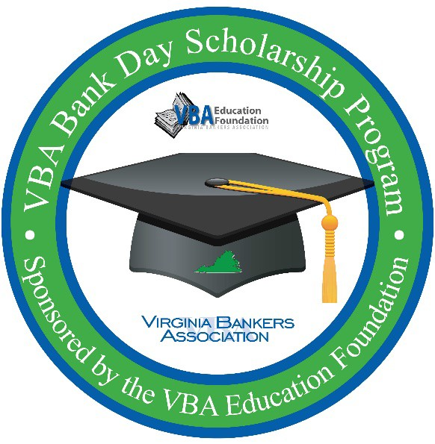
VBA Bank Day Scholarship Program
SAMPLE SCHEDULE

Sponsored by the VBA Education Foundation and the VBA Emerging Bank Leaders

Your Bank Day might include any of the following elements:

Bank Tour
You might take a tour around the branch: review the teller line, the teller window, and/or the vault, etc.

Careers in Banking Presentation
You might hear bankers tell their story of how they got into the banking industry and the different opportunities available to people who chose banking as a career path.

Understanding Credit & Managing Student Loans Presentation*
You might have members of the bank discuss the importance of establishing credit, understanding credit scores and making informed financial decisions about paying for college.

Department Visits
Your day might include meeting people in different departments of the bank. The representative will explain what he or she does at the bank with reference to how the job relates to the mission of the bank and how it affects the community. You will also learn about the bank’s financial literacy efforts*. Sample department activities include:

Commercial Lending Department - Going on a customer call or a visit from a business client in the community.

Human Resources Department - Completing a sample job application, discussing appropriate interview attire and participating in a mock interview.

Loan Department - Reviewing the loan process, the importance of good credit, and the importance of saving to become a qualified borrower*. You might complete a mock loan application to gain an understanding of the loan process.

Marketing Department - Learning how banks are involved in the community*.

Lunch with Banker Contact and Senior Management
You will end the day by spending time with your banker over lunch. You will have the opportunity to ask any questions you have about his or her job and duties. Other senior level bankers may join you.
*This information will be key in order for you to successfully complete your comprehensive essay.

