**Sample Disruption Letter**

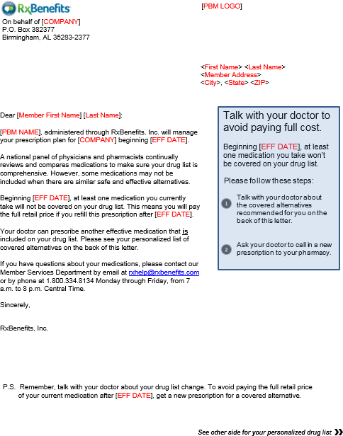

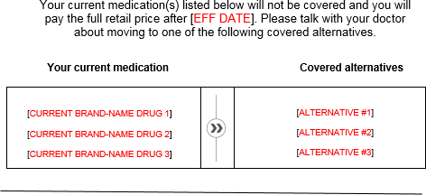

Additional covered alternatives may be available. Other prescription benefit considerations may apply. Costs for covered alternatives may vary. Call RxBenefits’ Member Services at 1.800.334.8134 for assistance.

**Sample Specialty Letter**

