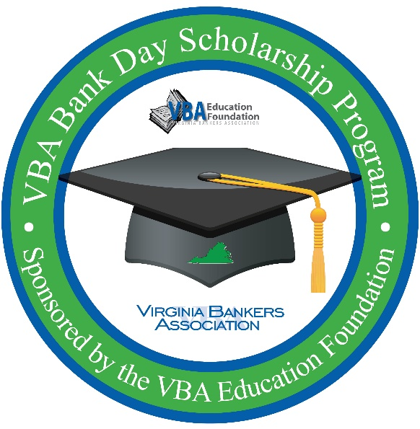
VBA Bank Day Scholarship Program
Fact Sheet

Sponsored by the VBA Education Foundation and
the VBA Emerging Bank Leaders

The third Tuesday in March was declared Bank Day by the Virginia General Assembly in 1991. On this day, high school seniors spend a day in banks across the Commonwealth shadowing a banker in their daily duties. The purpose of this experience is for the students to learn about banking, financial services, and the vital role banks play in their communities.

From their experience, the students are required to write an essay on their day. Seven scholarships (six regional and one statewide) will be awarded on the basis of the essays. There will also be six honorable mention scholarships of $1,000 (one in each of the six regions).

Bank Day will take place on [Tuesday, March 17th].

Participation Criteria:
Currently enrolled as a high school senior in a Virginia high school
Cumulative GPA of 3.0 or higher
Resident of Virginia
Teacher/guidance counselor contact information provided by student

Scholarship Amounts: $26,000 total!
$1,000 Each for six honorable mention scholarships
$2,500 Each for six regional winners
$5,000 Statewide winner ($7,500 total since all candidates will also be regional winners)

Deadlines & Important Dates
March 10, 2020: Deadline to sign-up for the program.
March 17, 2020: Bank Day! Shadowing takes place.
April 3, 2020: Student essays due by 5 p.m. Essays submitted directly to VBA via email.
April 24, 2020: Regional and honorable mention winners notified. Regional winners will be entered into the statewide contest for an additional $5,000 scholarship.
May 4, 2019: State winner notified.
Please contact [Bank Contact] at [email address] or [phone number] with questions.

